WEB ROUTING

USER MANUAL

SLIPPERY ROCK UNIVERSITY

Thomas Haley tjh1019@sru.edu

Sinchana Kori ssk1002@sru.edu

Beth Orgovan bro0700@sru.edu

Dakota Myers drm1022@sru.edu

Contents

1. Getting started – Home Page and Navigation 2

2. Login and users 3

2.1 REGISTRATION 4

2.1.1 shipper account registration 4

2.1.2 carrier account registration 6

3. ADMIN ACCOUNT 7

3.1 Add user 9

3.2 update/Edit user 10

3.3 DELETE user 11

3.4 View Available Roles 11

3.4 Database 12

3.5 Notification system 13

3.6 Update User details 13

4. SHIPPER USER 13

4.1 Update User Details 13

4.2 FREIGHT RATE TABLE 14

4.3 ADD SHIPMENTS 16

4.4 IMPORT shipments from EXCEL SHEET 17

4.5 DIRECT ASSIGN SHIPMENT 18

4.6 PUSH SHIPMENT TO AUCTION 19

4.7 SHIPPER AUCTION 19

4.8 FROZEN SHIPMENTS 20

4.9 notification System for Shipper Users 20

5. carriers 21

5.0.1 EDIT CARRIER 21

5.1 Import from excel When logged in as Carrier 21

5.2 Contacts 22

5.2.1 Add Contact 23

5.2.2 edit Contact 23

5.2.3 Delete Contact 24

5.3 Locations 24

5.3.1 ADD LOCATION 25

5.3.2 update/EDIT LOCATION 25

5.3.3 DELETE LOCATION 26

5.4 Vehicles 26

5.4.1 ADD VEHICLE 27

5.4.2 EDIT VEHICLE 27

5.4.3 DELETE VEHICLE 28

5.5 Vehicle types 28

5.5.1 ADD VEHICLE TYPE 29

5.5.2 EDIT VEHICLE TYPE 30

5.5.3 DELETE VEHICLE TYPE 31

5.6 SHIPMENTS - CARRIER 32

5.6.1 Available Shipment - CARRIER 32

5.6.2 Place/Edit Bids - CARRIER 32

5.6.3 Accepted Shipment – CARRIER 33

5.6.4 Awaiting Acceptance Shipment – CARRIER 34

5.6.4 all Shipment – CARRIER 34

5.7 Routes 35

5.8 Drivers 36

5.8.1 ADD DRIVER 36

5.8.2 Update/EDIT DRIVER 37

5.8.3 DELETE DRIVER 37

5.9 Technicians 38

5.9.1 ADD TECHNICIAN 38

5.9.2 EDIT TECHNICIAN 39

5.9.3 DELETE TECHNICIAN 40

5.10 Maintenance orders 40

5.10.1 ADD MAINTENANCE ORDER 40

5.10.2 EDIT MAINTENANCE ORDER 41

5.10.3 DELETE MAINTENANCE ORDER 42

5.11 Notification system for Carrier 42

6. AUCTIONEER 43

6.1 Edit User Details - auctioneer 43

6.1 auctioneer view of CARRIER 44

6.1.1 View carrier shipments 45

6.1.2 View Bids 45

6.2 shipments in auction 46

6.2.1 pending Shipments 46

6.2.2 FReeze SHIPMENTS 47

6.2.3 shipments awaiting acceptance 48

6.2.4 Available shipments 48

6.2.5 accepted shipments 49

6.3 Simulations 49

7. Shadow Admin 50

7.1 Logs 50

7.2 Filtering & Exporting logs 51

8. Figures 51

# 1. Getting started – Home Page and Navigation

Upon program launch, the user is greeted by the System home page **(Figure 1).** The user has the option to navigate to either the log-in page or the account registration page.

The side navigation bar (**Figure 1**) will present different options pertaining to the user’s role and is available across the application. It is collapsible via the ‘  ’ button in the top right of the navigation bar. The navigation bar can be expanded by clicking the ‘  ‘button (**Figure 2)**

Figure 1 - Home Page of System (Content-Push Nav-Bar Open)

Figure 2 - Home Page of System (Content-Push Nav-Bar Closed)

# 2. Login and users

A fresh installation of the program comes with the following default role accounts preinstalled:

|  |  |  |
| --- | --- | --- |
| **Default Credentials/Role** | **Username** | **Password** |
| **ADMIN** | AdminTry | AdminTry |
| **SHIPPER** | Shipper | Password |
| **CARRIER** | Carrier | Password |
| **MASTER LIST** | Auctioneer | Password |
| **SHADOW ADMIN** | ShadowAdmin | Password |
| **CARRIER** | ship4u | Password |

## 2.1 REGISTRATION

On the homepage, click **Create Account** or select the **Registration** tab on the sidebar to navigate to the **Registration Home** page **(Figure 3**).

This page provides general details of what features and functions each account type provides the user.

Figure 3 - Registration Home Page

### 2.1.1 shipper account registration

Figure 4 – Shipper Account Registration Page

Click the **SELECT** button under **SHIPPER** on the **Registration Home** page to register as a Shipper account. (**Figure 4**).

Shippers must provide the following:

* Username
* Password
* Email

The username must be **at least 6 characters long and LESS THAN 32 characters**.

The password MUST be **at least 8 characters long and LESS THAN 32 characters**.

An improper submission will prompt the user with an error message to identify any incorrect fields.

A proper form submission will load a captcha onto the screen for the user to validate that they are not a robot **(Figure 5)**.

After handling the captcha, the user will be redirected to the Login page which will display a message **“Your Account Has been Created Please Check Your Email to Verify Your Account.”**

Go to the email that was entered during registration.

Click the link found in the message sent from the Enterprise Routing Admin to Verify the Account.

Your new Shipper account is ready to use!

Return to the login page to login.

Figure 5 - Shipper Registration Page Captcha

2.1.2 carrier account registration

Figure 6 – Carrier Registration Page

Click the **SELECT** button under **CARRIER** on the **Registration Home** page to register a Carrier account **(Figure 6).**

The Carrier user must provide the following information during registration:

* **Username**
* **Password**
* **Email**
* **Carrier Name**
* **SCAC**
* **Pallets**
* **Weight**
* **Less-Than-Truckload (LTL)**
* **Full-Truckload (FTL)**

The Username MUST be **at least 6 characters long and LESS THAN 32 characters**.

The Password MUST be **at least 8 characters long and LESS THAN 32 characters**.

The Carrier Name **MUST not already exist** in the database.

The SCAC code MUST be **at least 2 characters long and NO MORE THAN 4 characters.**

An improper submission will prompt the user with an error message depending on what field was not filled in correctly.

After handling the captcha, the user will be redirected to the Login page which will display a message **“Your Account Has been Created Please Check Your Email to Verify Your Account.”**

Go to the email that was entered during registration.

Click the link found in the message sent from the Enterprise Routing Admin to Verify the Account.

Your new Carrier account is ready to use!

Return to the login page to login.

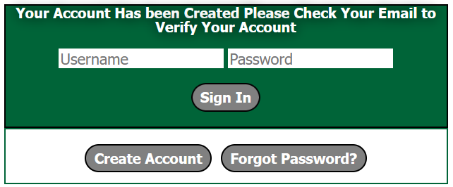

Figure 7 – Login Page

# 3. ADMIN ACCOUNT

Admin user has control over maintaining the other users such as Shippers, Carriers, Auctioneer.

Admin can add new users, edit each user's details, delete any carrier or shipper user, enable and disable each user and enable and disable each user from auctioning.

In general, Admin can see all users ID, their email address, if each user's account is enabled or disabled, if each users have ability to auction or not, and the role of each user. They can also add their carrier information for each Carrier users and have ability to change them after being created as well.

Logging in to Admin will land you in the All Users page that is listed under User’s tab in the navigation bar.

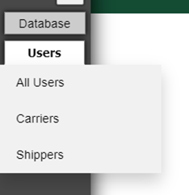

Figure 8 – Admin Account Navigation bar and Tabs

The ADMIN role has access to the following tabs and buttons:

**Users**: Navigates to a page displaying information for every registered user **(Figure 8)**. It gives a drop-down menu for choosing between All users, Shipper users, and Carrier users.

**All Users Page**: Lists all current users along with their details such as Carrier users, Shipper Users and Other users like Admin or Master List users. Ability to add, edit, delete all listed users. This page has the Add new User button when clicked it prompts the admin to choose what type of user they want to add, and view available roles button at the bottom of the page.

1. **All Shipper Users** contain a table which lists all the current shipper users and specifies if their account is enabled or disabled and if they have ability to auction or not.
2. **All Carrier Users** contain a table which lists all the current carrier users and specifies if their account is enabled or disabled and if they have ability to auction or not.
3. **All Other Users** contain a table which lists all the current admin and auctioneer users and specifies if their account is enabled or disabled.

**Note: Admin does not have permission to delete or edit Auctioneer and Admin accounts.**

**Carriers Page**: Lists all current Carrier users along with their details. Ability to Edit and Delete the existing Carrier Users. Add a New Carrier User tab for adding new carrier user with appropriate credentials and matching the validations, and View Available Roles Tab which lists the current roles and users associated with them.

**Shippers Page**: Lists all current Shipper users along with their details. Ability to Edit and Delete the existing Shipper Users. Add a New Shipper User tab for adding new shipper user with appropriate credentials and matching the validations and View Available Roles tab which lists the current roles and users associated with them.

**Note: There is no separate page for Other Users. It can only be found under “All User” under User’s tab.**

**View Available Roles**: This allows the admin to check what all roles are present in the system such as “SHIPPER”, “CARRIER”, “MASTERLIST”, “ADMIN”, and “SHADOWADMIN”. They can also see all the users associated with each role.

**Edit User**: Admin is able to edit each user details such as username, email address, is the user account is enabled or disabled, and if they have ability to auction or not. For carrier users, Admin can update or edit their carrier information along with the details mentioned previously.

**Delete User:** Deleting a user often throws a dependency conflict error.

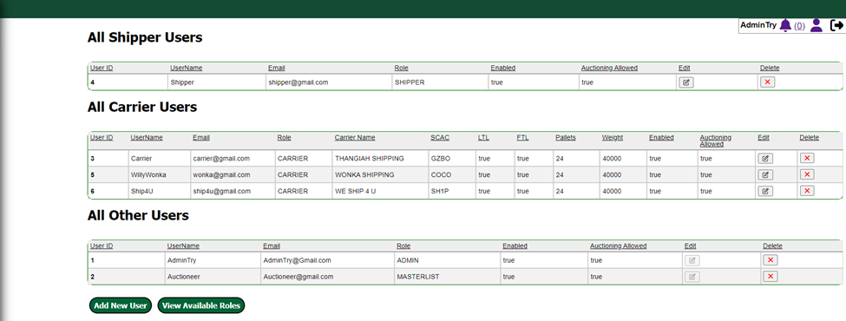

Figure 9 - Admin All Users Table and Home Page

## 3.1 Add user

Click the **Add a new user** to add a user.

The admin user will be redirected to a page that offers the option to add a user that either has the carrier role or a user that is a non-carrier role (Shipper User or Other User) **(Figure 10)**.

If the admin chooses to add a **Carrier** user, they will be redirected to Carrier Add page. Alternatively, the admin may add either a **Shipper** user by selecting **Shipper User** or **Admin** account or any other Non-Shipper and Non- Carrier users by selecting **Other User**. Doing so will bring the admin to a form page that lets the admin add users to the system. Each add user form varies respective to their roles.

**Note: All fields must be properly filled out for a user to be added to the system as per the required validations. Failing to do so will prompt a message indicating which field has the error.**

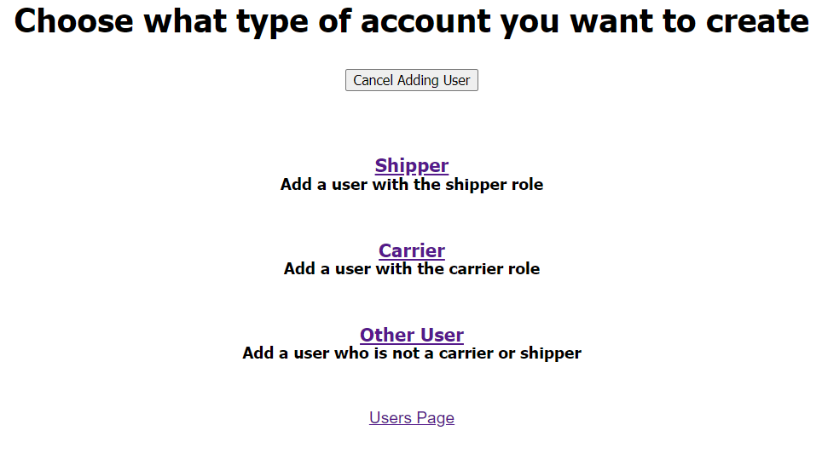

Figure 10 - Admin All User Add User Home Page

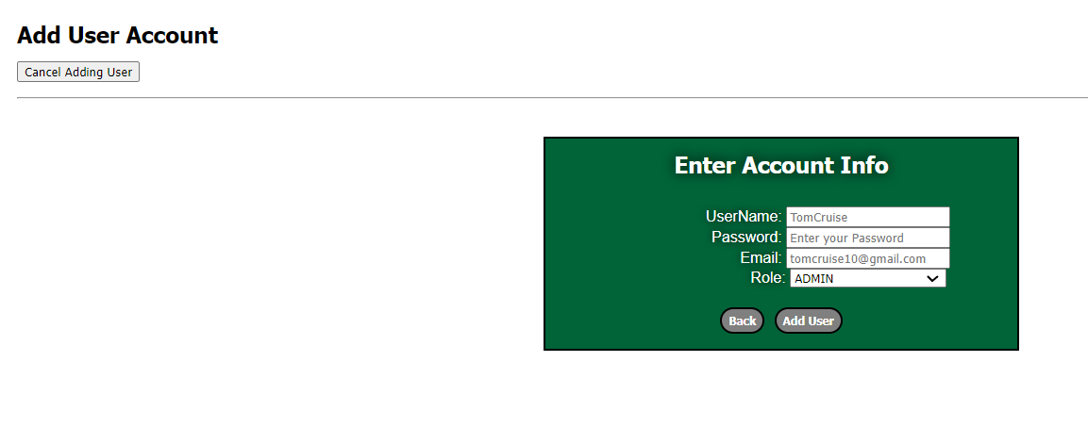

Figure 11 - Admin to Add Other User Page

## 3.2 update/Edit user

The admin can update or edit a user’s email, enable or disabling their accounts, ability of each user to auction for all CARRIER and SHIPPER accounts. For Carrier users, admin can edit or update carrier information along with the above-mentioned fields. The edit forms look quite similar to the add forms of respective users.



As Shown above, simply click **Edit** icon under **Edit column** present for each user to be redirected to the Update User page. Here, the admin can also prompt a password reset for the user.

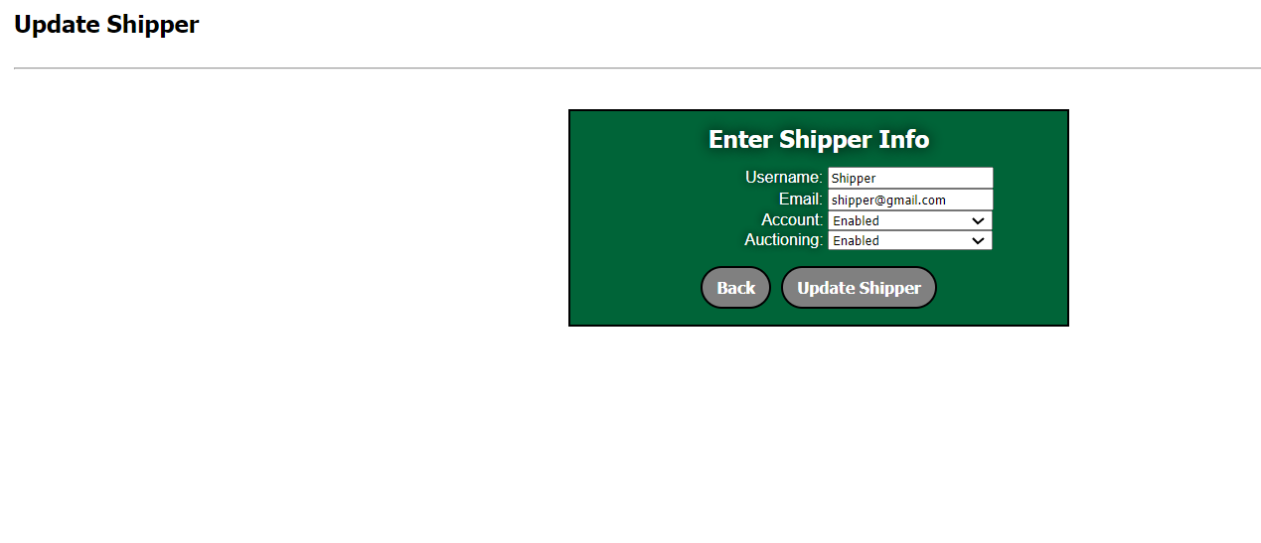

Figure 12 – Edit Shipper User Page

## 3.3 DELETE user

The admin can delete carrier, shipper, and other users from database except admin account itself and the auctioneer accounts. Admin cannot delete a user containing data that is dependent on it, for example, Admin cannot delete a shipper that contains any kind of shipments, and all of the bids for those shipments.



Deleting the user can be done by clicking on the Red Cross Button under the Delete column which is present for all current users. The picture above shows the delete icon under delete column.

The Admin User should see a delete confirmation dialog box that appears as a pop-up in the window to check if the user does indeed want to delete the that particular user. The user will not be able to be deleted if it is a part of the system elsewhere, a dependency conflict error message is shown for it. **(Figure 13)**

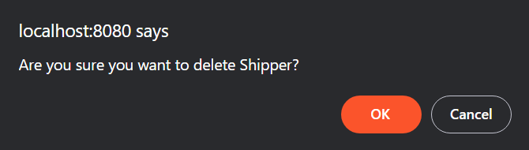

Figure 13 – Delete User Confirmation Pop-up above screen

## 3.4 View Available Roles

Every user account has a role assigned to it, and there are five roles in System: **ADMIN, SHIPPER, CARRIER, MASTERLIST, and SHADOWADMIN**.

On the All **Users** page **(Figure 9)**, click the **View Available Roles** button to navigate to the **Roles page** (**Figure 14**). Here, the admin can see each user associated with each of the five available roles. This view available roles button can also be seen in Carrier User page and Shipper User page along with All User page under User tab present in the navigation tab.

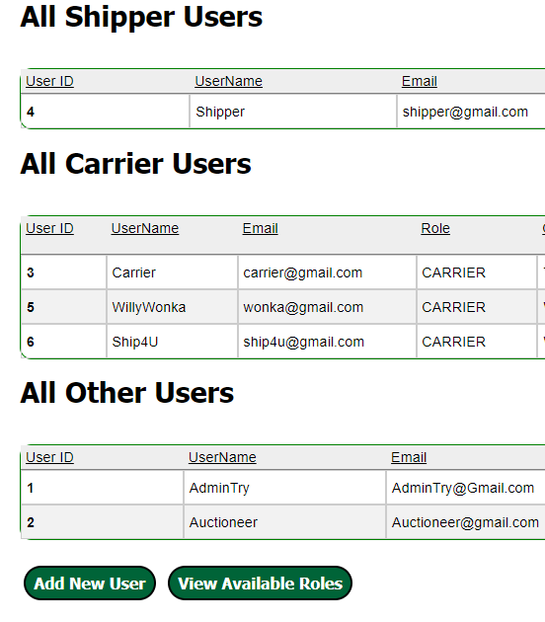

Figure 14 – View Available Roles Button in All User page

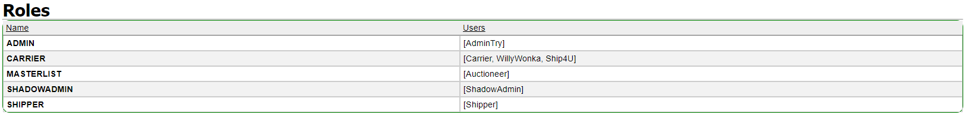

Figure 15 – User Associated with Roles Available in the System

## 3.4 Database

Admins may at any time reset the database to a backup from the **Database** screen. Backups are performed every twenty minutes and are saved to webrouting/backups. Backups are labeled with their data and time in the filename in following format: “backup MM_DD_YYYY_hh_mm.sql” **(Figure 16)**

**Note: Be aware that resetting the database to a backup drops the current contents of the database.**

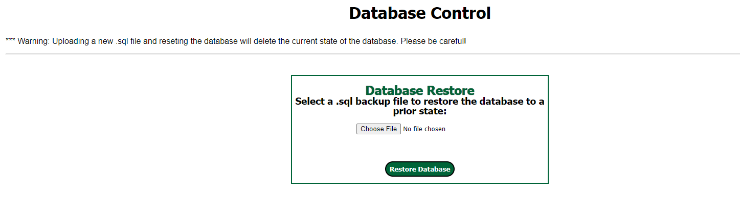

Figure 16 – Database Page in Database Tab

## 3.5 Notification system

Any kind of notification related to Admin Account can be found by clicking the “Bell” icon  which can be found top right corner of the application.

## 3.6 Update User details

Admin User has the capability to update all user account information and reset passwords, the users can also update their own emails and passwords.

After logging in, the home page will display the **User Icon** on the top right corner of the application when clicked, the user update details page will appear (**Figure 17**).

Upon clicking the **User icon**, the current user will be redirected to a form where they can update their password, and email address.

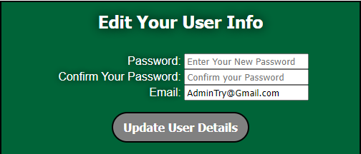

Figure 17 – Admin Update User Details

# 4. SHIPPER USER

Once a Shipper has been registered into the system and successfully logs in, they are directed to the All-Shipments Page. The All-Shipments page contains sections to show the status of all the shipments in the system.

## 4.1 Update User Details

Shippers has the capability to update their own emails and passwords.

After logging in, the home page will display the **User Icon** on the top right corner of the application  when clicked, the user update details page will appear (**Figure 18**).

Upon clicking the **User icon**, the current user will be redirected to a form where they can update their password, and email address.

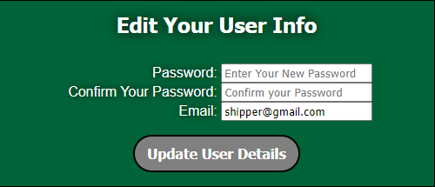

Figure 18 – Shipper Update User Details

To navigate the Shipper system, click on the tabs in the navigation bar shown below in **(Figures 19 and 20)**.

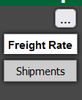

Figure 19 – Shipper Navigation Bar

Figure 20 – Shipper Navigation Bar and its Tabs

## 4.2 FREIGHT RATE TABLE

The Freight Rate Table system allows shippers to set default price-per-mile multipliers for shipments. This allows shippers to pre-generate prices for shipments when they are assigning shipments to carriers outside of the auction.

To upload a Freight Rate Table or to view current tables, select the Freight Rate tab on the navigation bar . This will bring up the **Upload File** page where a file can be browsed to and selected for upload.

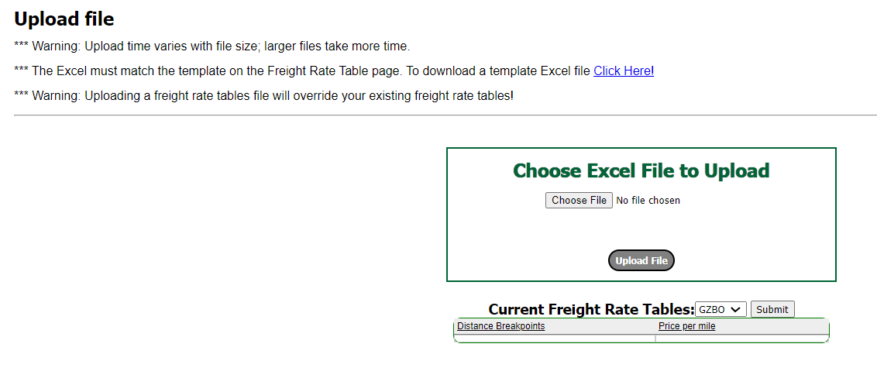

Figure 21 – Upload Page for Freight Rate Table

The application provides an Excel template for each excel or .csv file uploads. A template for Freight Rate able can be downloaded by clicking on  link and save it in the desired location. For uploading the Freight Rate table excel sheet, click on  button and navigate to the file path to where you locally saved the template excel sheet. Once you choose a file, click on  button.

The file has DISTANCE and PRICE PER MILE fields and requires the sheet names of the Excel file to be SCAC numbers of existing carriers.

**\*Note that Sheets with SCACs for nonexistent carriers will be ignored.**

At the bottom of the page, select the SCAC for any carrier in the system and click on  button to view your freight rate table for that carrier, if you have one (Figure 14).

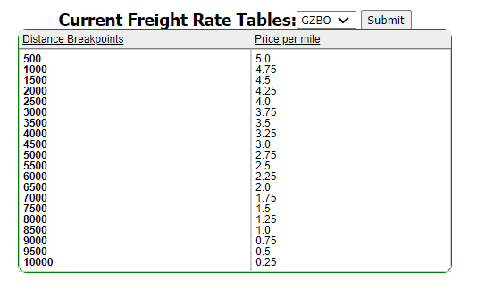

Figure 22 – Freight Rate Table for SCAC – GZBO in Upload Freight Table Page

Once a Freight Rate Table has been uploaded, the  button on the Direct Assignment screen will be enabled **(Refer 3.2 ADD SHIPMENTS)**. The system allows shippers to have multiple Freight Rate Tables to allow for different pricing for different carriers.

When assigning a price to the shipment using a freight rate table, a query is made to Google Maps API to determine the distance between the shipment start and ending location. That distance is matched against the "Distance Breakpoints" in your freight rate table to determine a price per mile, and then the distance is multiplied by that rate. The resultant price will be automatically filled into the input box.

## 4.3 ADD SHIPMENTS

Shippers can add shipments either by importing through excel (Refer Section 3.3) or by adding them manually by clicking on  which is present at the top of the All shipments page and below the shipments table in Pending Shipments page.

Form fields for shipments are as follows:

* **Client:** The shipper entity commerce is being shipped by the carrier. (Ex. Marrakesh Shipping)
* **Client Mode:** Whether the client requires FTL or LTL for the shipment.
* **Ship Date:** The scheduled date of the shipment (Ex. 07/15/2023)
* **Commodity Class:** Class of the commodities being shipped (Ex. 12)
* **Commodity Pieces:** Number of pieces being shipped (Ex. 500)
* **Commodity Paid Weight:** Weight of the shipment (Ex. 7500)
* **Shipper City:** Starting city commerce is being shipped from (Ex. Cincinnati)
* **Shipper State:** Starting state commerce is being shipped from (Ex. OH)
* **Shipper Zip:**  Starting zip code commerce is being shipped from (Ex. 23066)
* **Consignee City:** Destination city commerce is being shipped to (Ex. Scranton)
* **Consignee State:** Destination state commerce is being shipped to (Ex. PA)
* **Consignee Zip:** Destination zip code commerce is being shipped to (Ex. 19202)

Clicking on **Add Shipment,** Add Shipment Info form as seen below.

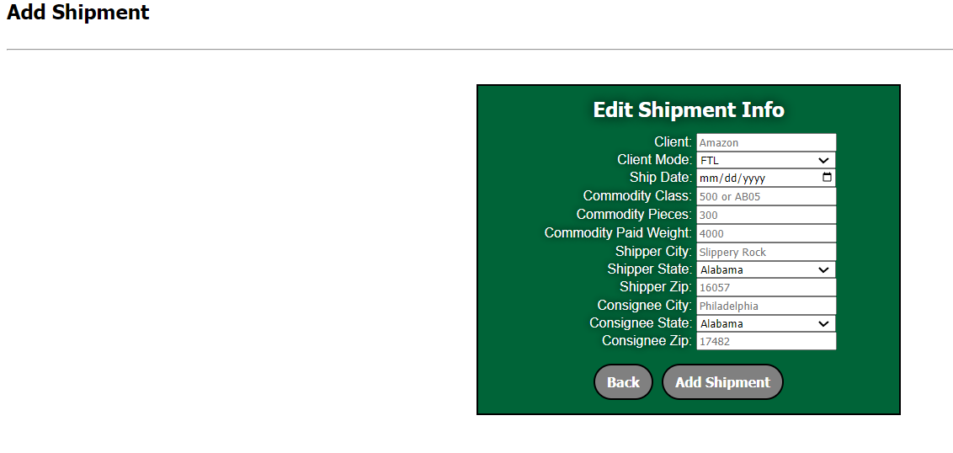

Figure 23 - Add a New Shipment Page

## 4.4 IMPORT shipments from EXCEL SHEET

This feature allows multiple shipments to be uploaded in the form of a csv file. **NOTE:** The csv **MUST** be in the **EXACT** format given in the template file.

To upload shipments from an Excel sheet, click on the  button which is present above of the All Shipments page or below the table present in the Pending Shipments page.

This will bring up the upload shipments page where a file can be browsed to and selected for upload.

Figure 24 - Upload Excel File Page after clicking on Import Excel Sheet.

The application provides an Excel template with the correct formatting necessary for uploading into the system. Click on  link to download it locally to the desired location by filling out the necessary fields for saving the shipments excel sheet. For uploading the template excel sheet, click  button to navigate to where it is saved. Once the file is chosen, click the  button.

If the upload is successful, it will redirect back to the Shipments page where the Import Excel Sheet button was clicked, (all shipments or pending shipments) and a success message will be displayed above the screen **(Figure 25).**



Figure 25 – Upload shipment from excel success message.

If there are errors in the file, the system will remain on the upload shipment page and display an error message **(Figure 26).**



Figure 26 – Upload shipment from excel error message.

**Note: Open your Excel sheet to determine what fields need to be corrected and try to upload again.**

Once the shipments are loaded into the system, they will be displayed in the **Pending Shipment** table. The shipments are now ready to be directly assigned to a Carrier or pushed into the Auction.

## 4.5 DIRECT ASSIGN SHIPMENT

This feature can be used to select a Carrier in the system and directly assign them a shipment.

To directly assign a shipment to a Carrier in the system, click on the “**Direct Assign”** button, which will bring up the page to select a Carrier **(Figure 27).**

Select the **Carrier to assign** the shipment to. From there, a price can be entered or fetch the price from the Freight Rate Table.

Figure 27 – Carrier to Assign Shipments Page

If a Freight Rate Table has been uploaded **(Section 3.1)** clicking on  button will auto-populate the Price (if the shipper has a freight rate table for the selected carrier) **(Figure 27).** Finally, click on  button to Direct Assign the shipment.

Once a shipment has been assigned to a Carrier, the shipment will be moved into the **Shipments Awaiting Acceptance** table **(Figure 21)**. Which can be viewed on the All-Shipments page or the Awaiting Acceptance Shipments pages.

Figure 28 – Shipment Directly Assigned moved under Shipment Awaiting Acceptance Table

**Note: The acceptance of the shipments by the carrier is done by Carrier User (Refer to Section 5.6.4).**

## 4.6 PUSH SHIPMENT TO AUCTION

A shipment can be pushed into the auction for Carriers to bid on, with the lowest bid winning the auction.

To push a shipment into the auction, click the **Gavel** icon under **Push to Auction** column of the selected shipment.



The Shipper should see a confirmation pop-up on the top of the window to ensure that the correct shipment ID has been selected for pushing into auction **(Figure 29)**. If the correct shipment is being pushed then click **OK** or if it is not the correct shipment then click **Cancel**.

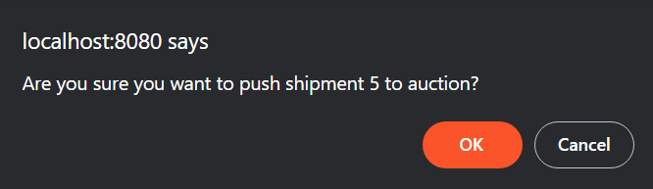

Figure 29 - Push Shipment Confirmation Pop-up above screen

**Note: The theme of the browser might change the color of the pop-ups.**

The shipments pushed to auction from the **Pending Shipments** will now be displayed in the **Available Shipments**, as show below **(Figure 30).** The shipment has now entered the auction.

Figure 30 – Available Shipment Page after pushing shipment from Pending Shipments

## 4.7 SHIPPER AUCTION

Once shipments are in the auction, they can be bid on by Carriers. The Shipper can do the following with shipments in Auction/Available status:

* Edit the details.
* Delete Shipment
* Remove From Auction
* View Bids

**Edit Details**: All the details of the Shipment can be edited.

**Delete Shipment**: This will delete the shipment from the system entirely. Clicking Delete will trigger a popup to make sure that you do indeed want to delete the shipment. From here, click “OK” to delete the shipment or “Cancel” to cancel the deletion.

**Remove From Auction**: Shipment may be removed from auction by clicking the “Remove from Auction” button. This will trigger a popup that asks to make sure that you want to remove the shipment ID from auction. Click “Cancel” to cancel or Click “OK” to remove the shipment. Another popup will confirm that the shipment has been removed from auction. The shipment is then moved back to the **Pending Shipments** table.

**View Bids**: When a Carrier bids on a shipment, they will show up in the **viewshipmentbids** page **(Figure 31).** Click on the “View Bids” button to navigate there to view the bids and their details.



Figure 31 – Shipment Bids page

To accept a bid, click  on the bid you want to accept.

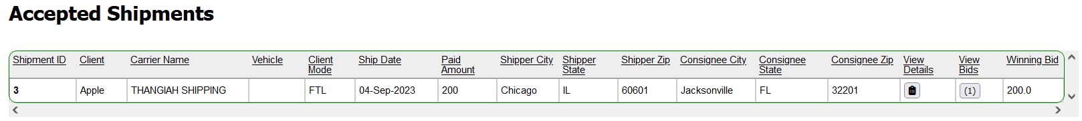

Figure 32 – Accepted Shipments Page after Accepting Bid on Figure 31

Once a bid is accepted, it will be moved from **Available Shipments** into the **Accepted Shipments** table **(Figure 32).** The Auction process is now over.

## 4.8 FROZEN SHIPMENTS

While shipments are in the auction, they can be put into a Frozen state by the **Auctioneer (Detailed in section 6.2.2).** Frozen state technically takes the shipment out of the auction by changing their status from **Available** to **Frozen** and are moved into the **Frozen Shipments** table **(Figure 33).** The Carrier cannot see shipments while they are frozen. Only the Auctioneer can unfreeze the shipment.

Figure 33 – Frozen Shipment Page

## 4.9 notification System for Shipper Users

Shippers will get notifications for the following events:

* A shipment has been deleted.
* New bid is placed on a shipment.
* A shipment is Frozen by the Auctioneer
* A shipment is Unfrozen by the Auctioneer

Figure 34 – Shipper Notification System Page

The Notification count will be displayed in the top right corner or the page beside the bell icon. Click on the bell to go to the Notifications page **(Figure 34)**.

Notifications can be  individually or all at once by clicking the  button. The number of unread notifications the user currently has is displayed in parentheses next to the notification button on all screens **(Figure 34)**.

# 5. carriers

The **Carriers** tab show all relevant (depends on user type) information on carriers that are registered in the system.

It is accessible by **MASTER LIST** and **CARRIER** users.

### 5.0.1 EDIT CARRIER

**CARRIER** users are permitted to edit their own carrier information. To edit carrier information, click **Edit** icon under the **Edit Column** on the **Carriers** page. The user will be redirected to a form (**Figure 19**) where they can alter all carrier fields.

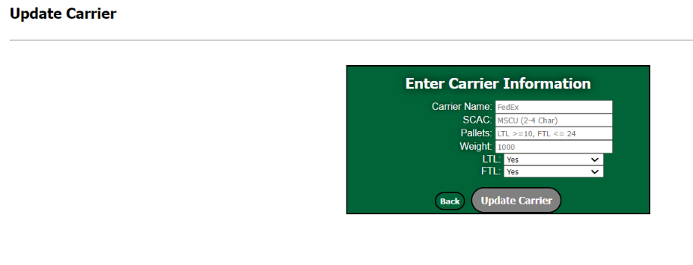

Figure 35 - Updating Carriers Page

## 5.1 Import from excel When logged in as Carrier

This feature allows multiple shipments to be uploaded in the form of a csv file. **NOTE:** The csv **MUST** be in the **EXACT** format given in the template file.

To upload Excel sheet for the tabs present in the Navigation bar when logged in as Carrier, click on the  button which is present right at the bottom of each page next to **Add New** button.

This will bring up the **Upload File** page where a file can be browsed to and selected for upload.

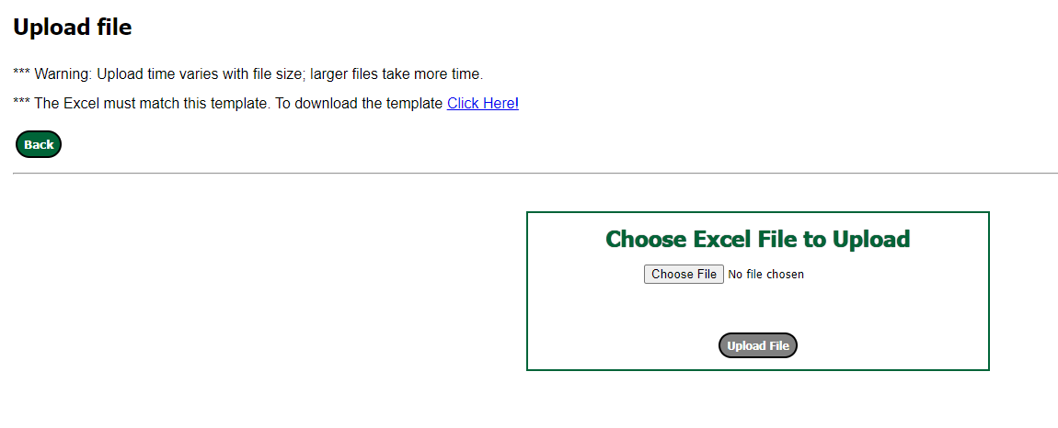

Figure 36 – Upload Excel File Page after clicking on Import Excel Sheet.

The application provides an Excel template for every other **Import Excel Sheet** button that is present under Contacts, Drivers, Locations, Maintenance Orders, Technicians, Vehicles and Vehicles types with the correct formatting necessary for uploading into the system which can be seen when logged in as Carrier User. For downloading the particular template, click on  link to download it locally onto the desired location by filling out the necessary fields for saving the particular excel sheet.

For uploading the template excel sheet, click on  button to navigate to where it is saved. Once the file is chosen, click the  button.

If the upload is successful, it will redirect back to the respective home page where the Import Excel Sheet button was clicked and a success message will be displayed on top of the page. Below picture is an example for a success message after uploading Contacts Excel sheet successfully **(See Figure 37).**



Figure 37 – Upload Contacts from excel success message

If there are errors in the file, the system will remain on the Upload File page itself and display an error message on the top of the screen as seen below in **(Figure 38).**



Figure 38 – Error message for incorrect excel file or wrong format of desired excel file

**Note: Open your Excel sheet to determine what fields need to be corrected and try to upload again.**

Once the desired excel sheet are loaded into the system, they will be displayed in therespectivemain page as a table.

## 5.2 Contacts

The **Contacts** tab redirects **CARRIER** users to a page with that carrier’s list of contacts.

The table contains the name, contact information, and geolocational information for all contacts in the carrier’s book of business **(Figure 39).**

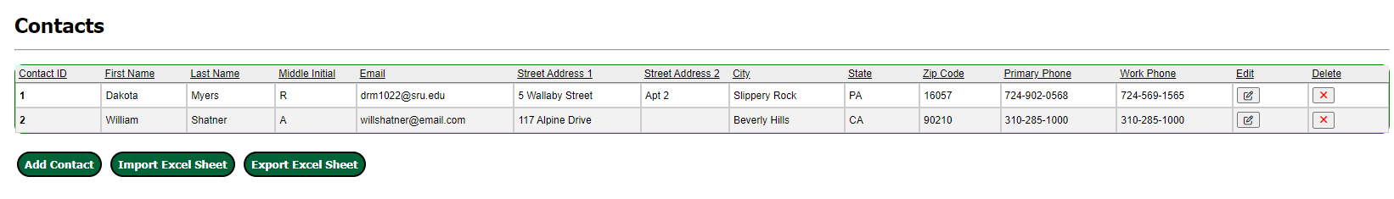

Figure 39 - Contacts Page for Carrier Users

### 5.2.1 Add Contact

To add a contact, Click the **Add Contact** Button which is present right below the table. This will redirect the user to a form containing the following fields for a contact’s information:

* **First Name** (Ex. John)
* **Last Name** (Ex. Williams)
* **Middle Initial** (Ex. R)
* **Email Address** (Ex. johnrwilliams@gmail.com)
* **Street Address 1** First line of address (Ex. 662 Grant Street)
* **Street Address 2** Second line of address (Ex. Ste 3000)
* **City** (Ex. Las Angeles)
* **State**  Drop down list of states
* **Zip Code** Five-digit required (Ex. 90210)
* **Primary Phone**  (Ex. 310-456-7890)
* **Work Phone (if applicable)** (Ex. 310-456-7890)

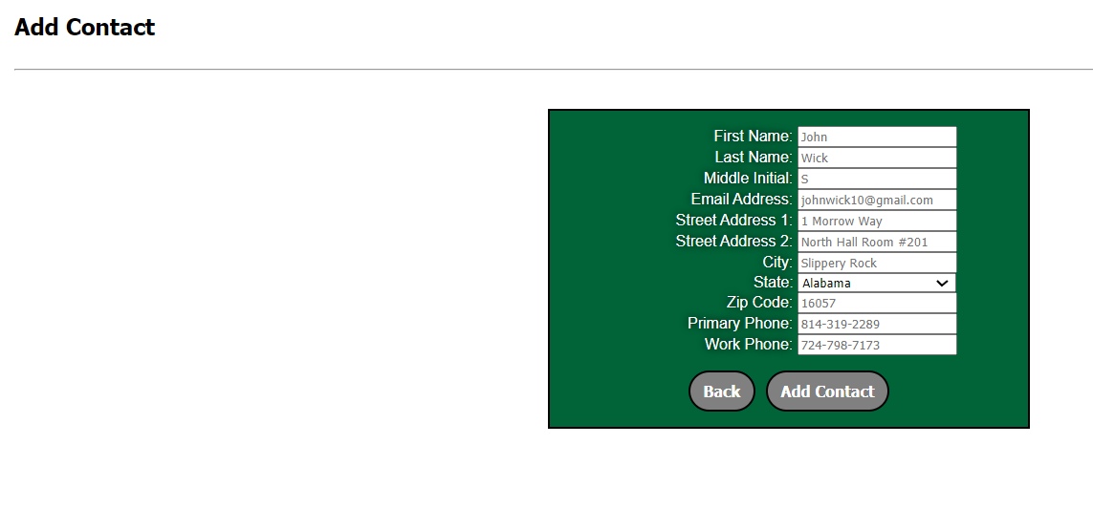

Figure 40 – Form for Carrier to Add a Contact

### 5.2.2 edit Contact

To edit a contact, click the **Edit** icon under the **Edit Column** on the **Contacts** page for any particular contact that needs to be edited in the data table.



The Carrier user will be redirected to a form identical to the **Add Contact** form seen above in **Figure 40.** The user can update all the original fields entered for the contact.

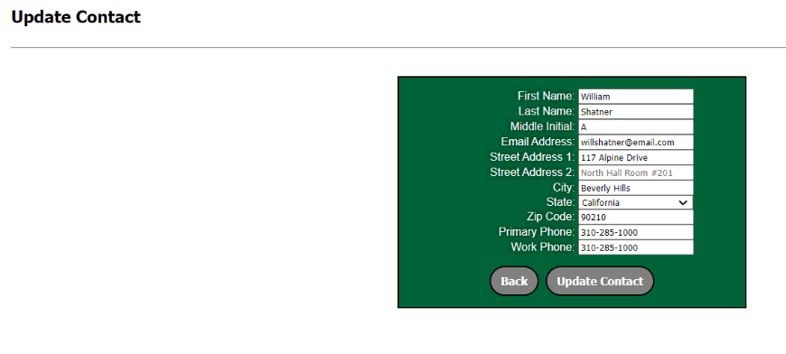

Figure 41 - Form for Carrier to Edit a Contact

### 5.2.3 Delete Contact

To delete a contact, click the **Red Cross Icon** under **Delete Column** in the table row of the desired contact.



The Carrier user should see a delete confirmation dialog box which pops-up on the window after clicking red cross delete icon asking whether the user wants to delete that particular contact, where they can select **Ok** to delete the contact or **Cancel** to keep the contact. **(Figure 42)**

If the Contact is attached to another object, it cannot be deleted and gives the error: Unable to delete due to dependency conflict.

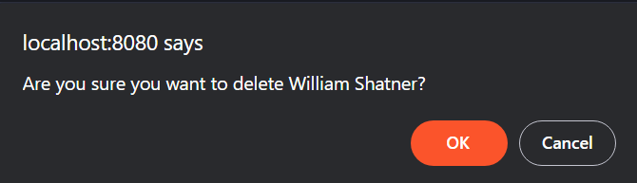

Figure 42 - Delete Contact Confirmation Pop-up above screen

## 5.3 Locations

The **Locations** tab lands the user on a page displaying all relevant information on locations registered to carriers in the system. These locations may be trucking depots, fueling stations, maintenance shops, intermediate hubs, etc. **CARRIER** users can use the locations page **(Figure 43)** to view, add, edit, and delete locations associated with their account.

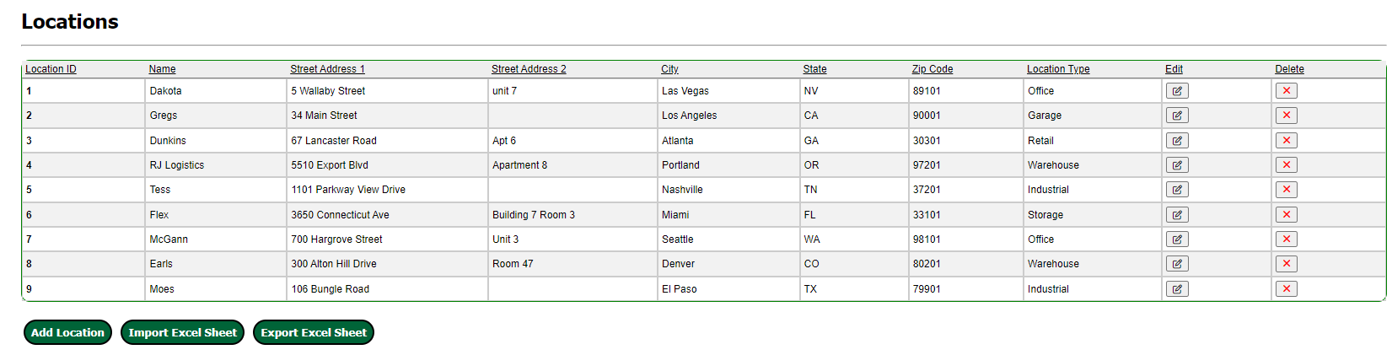

Figure 43 - Locations Page for Carrier Account

### 5.3.1 ADD LOCATION

To add a location, click the **Add Location** button.

The user will be redirected to a page with a form **(Figure 44)** containing the following required fields for a location:

* **Location Name** (Ex. John’s Warehouse)
* **Street Address 1** First line of address (Ex. 662 Grant Street)
* **Street Address 2** Second line of address (Ex. Ste 3000)
* **City** (Ex. Las Angeles)
* **State:**  Drop down list of states
* **Zip Code** Five-digit required (Ex. 90210)
* **Location Type** (Ex. Warehouse, Hub, Fuel Depot)

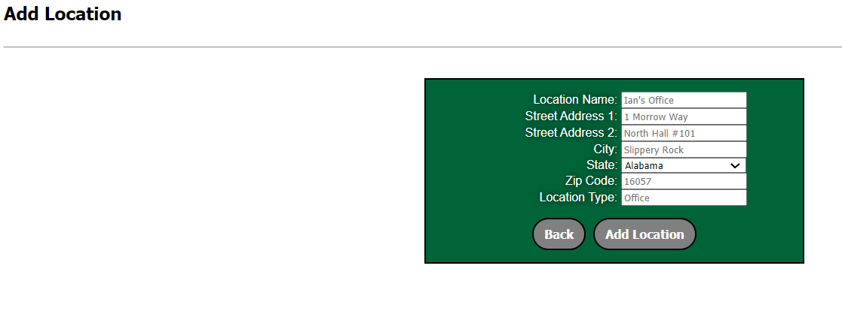

Figure 44 - Form to Add New Location

### 5.3.2 update/EDIT LOCATION

To edit a location, click the **Edit** icon under the **Edit Column** on the **Locations** page for any particular location that needs to be edited in the data table.



The Carrier user will be redirected to a form identical to the **Add Location** form seen above in **Figure 44.** The user can update all the original fields entered for the location.

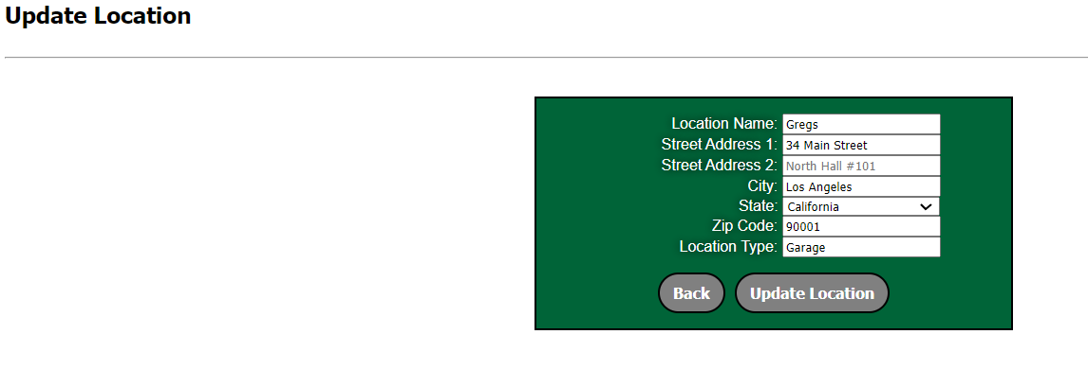

Figure 45 - Form to Edit Location

### 5.3.3 DELETE LOCATION

To delete a location, click the **Red Cross** iconunder **Delete** column on the **Locations** page for that particular location in the data table.



The Carrier user should see a delete confirmation dialog box **(Figure 46)** which pops-up on the window after clicking **red cross delete** icon asking whether the user wants to delete that particular location, where they can select **Ok** to delete the location or **Cancel** to keep the location.If the Location is attached to another object, it cannot be deleted and gives the error: Unable to delete due to dependency conflict.

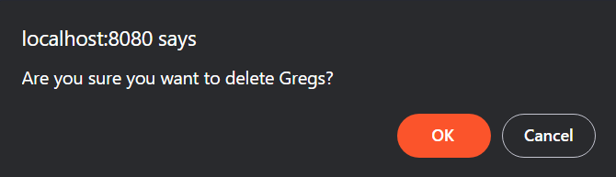

Figure 46 - Confirmation Dialog Pop-up Box to Delete Particular Location

## 5.4 Vehicles

The **Vehicles** tab lands the logged in **CARRIER** user on a page displaying all relevant information on existing vehicles registered to that user **(Figure 47)**.

To add a new vehicle, click the **Add New Vehicle** button.

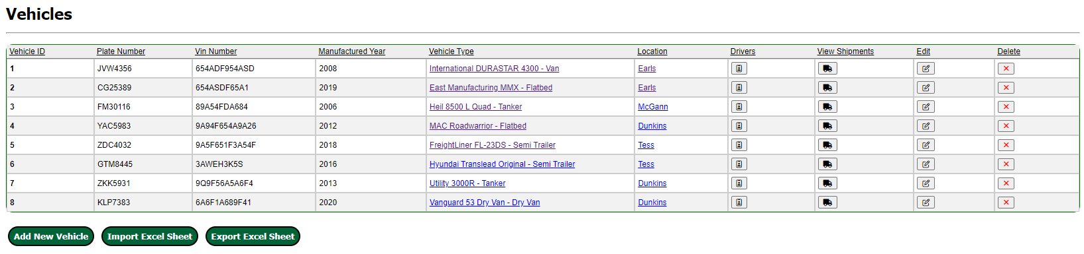

Figure 47 - Vehicles Home Page for Carrier Accounts

### 5.4.1 ADD VEHICLE

Upon clicking the **Add New Vehicle** button on the Vehicles, the user will be redirected to a form page **(Figure 48)** where all relevant fields to a vehicle can be entered.

The fields are as follows:

* + **Plate Number**: Vehicle’s License Plate (Ex. – 11479TE)
  + **VIN Number:** Vehicle’s 17-character Vehicle Identification Number (Ex. 1G1AF1F57A7192174)
  + **Manufactured Year:** The year the vehicle was manufactured (Ex. 2020)
  + **Vehicle Type:** Choose from a list of the created Vehicle Types (Section 6)
  + **Location:** Where the vehicle is kept when not in use. Selected from a list of the created Locations (Section 4). (Ex. John’s Warehouse)

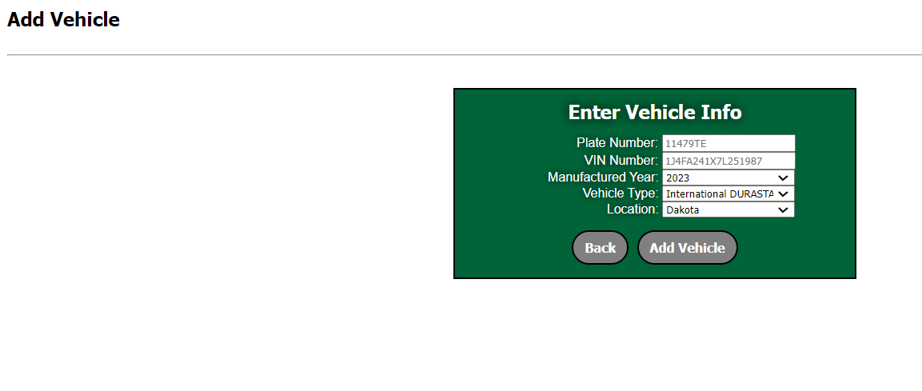

Figure 48 - Form for Carrier to Add a Vehicle

### 5.4.2 EDIT VEHICLE

To edit a vehicle’s information, click on the **Edit** **icon** under **Edit column** for every vehicle listed on the data table found on the Vehicle home page **(Figure 49)**.



The Carrier user will be brought to a form page identical to the **Add Vehicle** form seen in **Figure 49**. Here, the **CARRIER** user can alter any/all information for the specific vehicle they choose to edit.

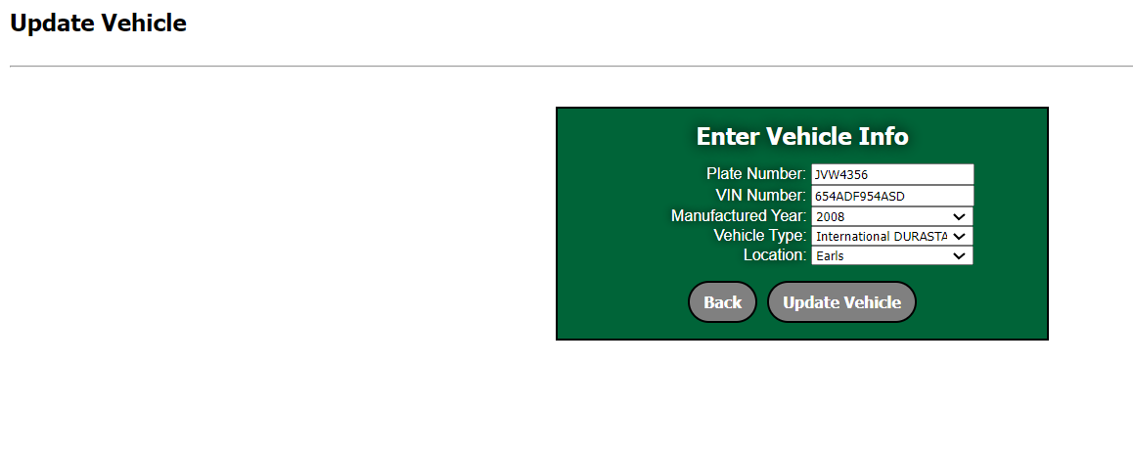

Figure 49 - Form for Carrier to Edit Vehicle

### 5.4.3 DELETE VEHICLE

To delete a location, click the **Red Cross** iconunder **Delete** column on the **Vehicles** page for that particular vehicle in the data table **(Figure 47)**.



The Carrier user should see a delete confirmation dialog box **(Figure 21)** which pops-up on the window after clicking **red cross delete** icon asking whether the user wants to delete that particular vehicle, where they can select **Ok** to delete the vehicle or **Cancel** to keep the vehicle.

If the Vehicle is attached to another object, it cannot be deleted and gives the error: Unable to delete due to dependency conflict.

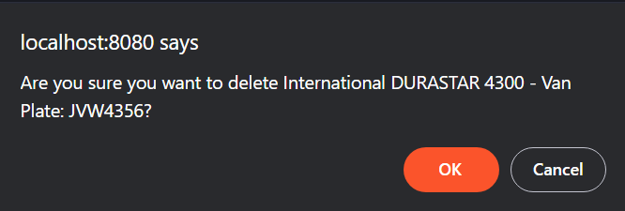

Figure 50 - Confirmation Dialog Pop-up Box to Delete Particular Vehicle

## 5.5 Vehicle types

The Vehicle Types tab lands the **CARRIER** user on a page **(Figure 51)** containing relevant information on the different kinds of vehicles that are registered with the system.

This page grants **CARRIER** user permissions to add, edit, and delete vehicle types on the system.

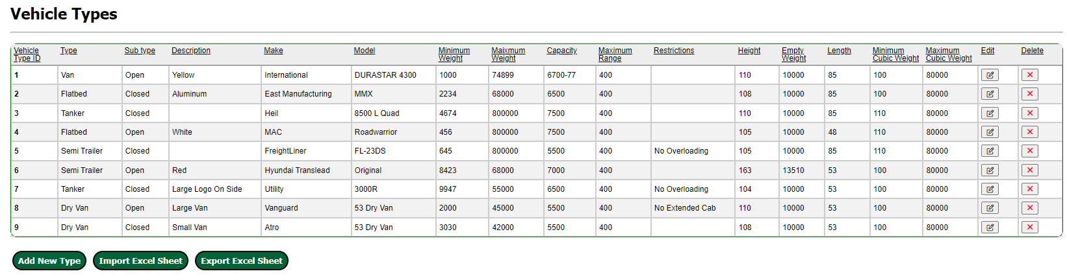

Figure 51 - Vehicle Types Home Page

### 5.5.1 ADD VEHICLE TYPE

To add a vehicle type, click on the **Add New Type** button on the data table found on the **Vehicle Types** home page. The user will be redirected to a form page **(Figure 52)** used to fill out all relevant information for the vehicle type.

The required fields are as follows:

* + **Type:** The main type of the vehicle (Ex. Freight Truck)
  + **Sub Type:** The sub type of the vehicle (Ex. Dual-Trailer)
  + **Description:** A brief description of the vehicle type
  + **Make:** The make of the vehicle (Example: Peterbuilt)
  + **Model:** The model of the vehicle (Example: Model 579)
  + **Minimum Weight:** The vehicle’s minimum freight weight (Example: 10,000)
  + **Maximum Weight:** The vehicle’s maximum freight weight capacity in lbs. (Example: 40,000)
  + **Capacity:** How much the vehicle can hold (Example: 3000)
  + **Maximum Range:** The maximum range vehicle type is intended for freighting (Example: 1500km)
  + **Restrictions:** Traveling restrictions for vehicle type (Ex. Maximum height for tunnels/overpasses)
  + **Height:** The vehicle’s height in feet (Ex. 12.25)
  + **Empty Weight:** The weight of the unloaded vehicle in lbs. (Ex.8000)
  + **Length:** The length of the vehicle in feet (Ex. 25.5)
  + **Minimum Cubic Weight:** The minimum cubic weight of the vehicle type (Ex. 0)
  + **Maximum Cubic Weight:** The maximum cubic weight of the vehicle type (Ex. 5000)

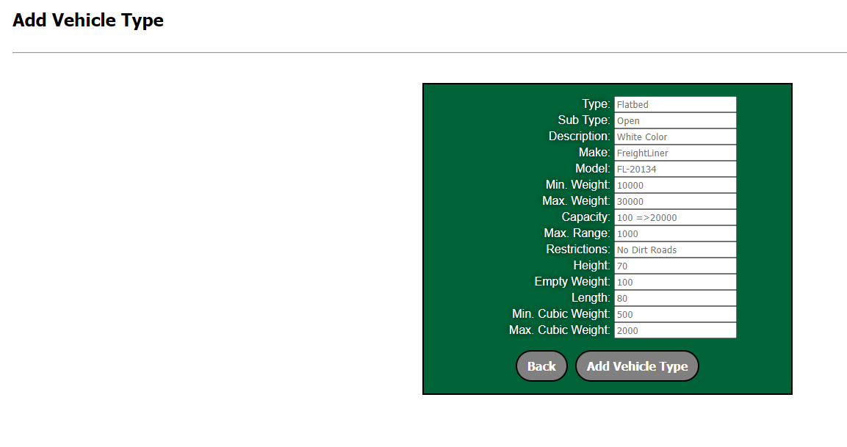

Figure 52 – Form for Carriers to Add a New Vehicle Type

### 5.5.2 EDIT VEHICLE TYPE

To edit a Vehicle Type’s information, click on the **Edit** **icon** under **Edit column** for every vehicle type listed on the data table found on the Vehicle Type home page (**Figure 22**).



The Carrier user will be brought to a form page identical to the **Add Vehicle** form seen in **Figure 53**. Here, the **CARRIER** user can alter any/all information for the specific **Vehicle Type** they choose to edit.

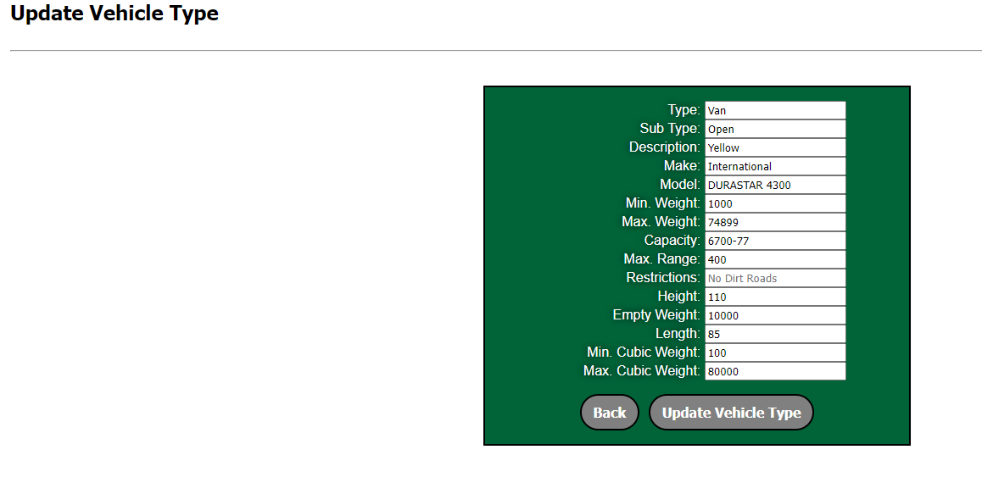

Figure 53 – Form for Carriers to Edit Vehicle Type

### 5.5.3 DELETE VEHICLE TYPE

To delete a location, click the **Red Cross** iconunder **Delete** column on the **Vehicle Type** page for that particular vehicle type in the data table **(Figure 51)**.



The Carrier user should see a delete confirmation dialog box **(Figure 54)** which pops-up on the window after clicking **red cross delete** icon asking whether the user wants to delete that particular vehicle, where they can select **Ok** to delete the vehicle or **Cancel** to keep the vehicle.

If the Vehicle is attached to another object, it cannot be deleted and gives the error: Unable to delete due to dependency conflict.

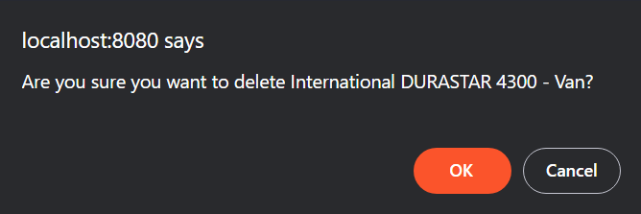

Figure 54 – Confirmation Dialog Pop-up Box to Delete Particular Vehicle Type

## 5.6 SHIPMENTS - CARRIER

The **CARRIER** accounts are the accounts that bid on shipments. They are responsible for freighting the shipments from source to destination. The interactions **CARRIER** accounts have with shipments are detailed below.

### 5.6.1 Available Shipment - CARRIER

The **CARRIER** account view of the **Available Shipments** page **(Figure 55)** displays a table containing that user’s shipment records with associated information. Here, the user can view all bids on an available shipment or add a bid on one themselves.

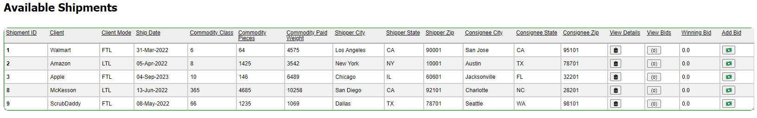

Figure 55 - Carrier View of the Available Shipments Page

### 5.6.2 Place/Edit Bids - CARRIER

The **CARRIER** user can place bids on shipments by clicking the “**Money” Icon** 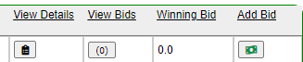under **Add Bid** column. It will redirect the user to the **Add Bid** form page **(Figure 56)** from the Available Shipments pagewhere the bid price can be entered.

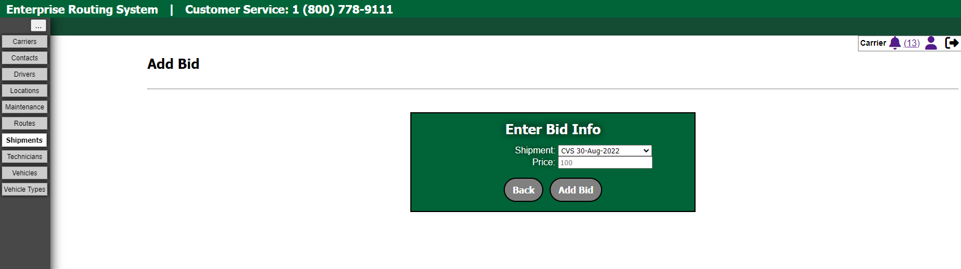

Figure 56 - Form to Add a Bid

information by clicking “**(number)” icon** 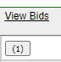 under **View Bids** column present in the **Available Shipment** page and then click on the **Edit** icon which appears in the **Bids Page** for editing the Bids for the desired shipment. The icon redirects the user to the **Update Bid** page **(Figure 57)** where the bid price and shipment information can be edited.

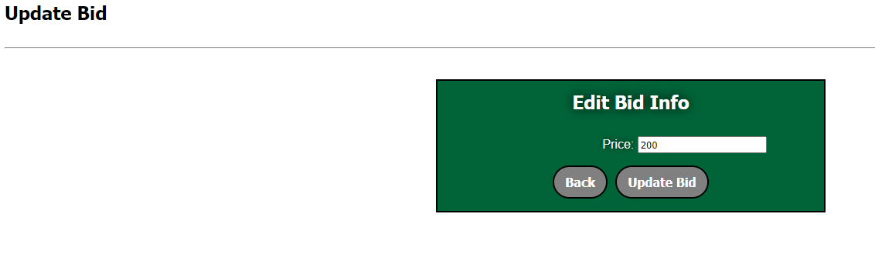

Figure 57 - Form to Edit a Bid in Available Shipment

### 5.6.3 Accepted Shipment – CARRIER

The **CARRIER** account view of the **Accepted Shipments** page **(Figure 58)** displays a table containing that user’s accepted shipment records associated with that account. These are the jobs the carrier company has accepted. On this page, the user can view details of shipments view bids, and assign a vehicle to shipment.

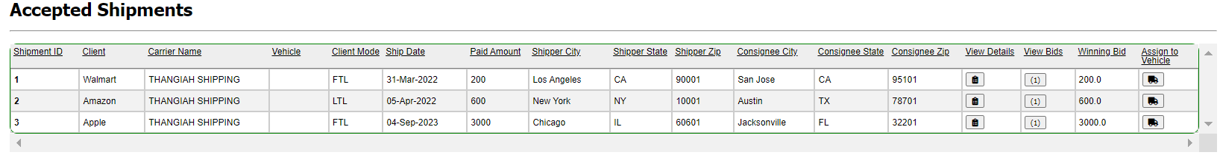

Figure 58 - Carrier View of Accepted Shipments for that Carrier

To view the details of a shipment, click the “**Clipboard” icon **under **View All Details** column on the **Accepted Shipments** page **(Figure 58).** The user will be redirected to a page detailing all aspects of the shipment **(Figure 59)**. It also includes Google Maps links to both locations by coordinates as well as the route between locations (At Page Bottom).

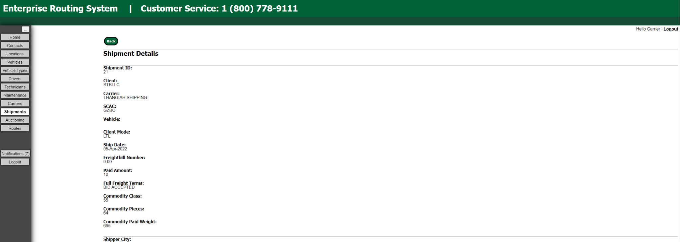

Figure 59 - Carrier View of Shipment Details Page

#### 5.6.3.1 assign vehicle to Shipment – CARRIER

To assign a vehicle for a desired shipment, click the “**Truck”** icon 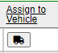 under **Assign to Vehicle** column on the **Accepted Shipments page**. It will redirect the Carrier user to the below page:

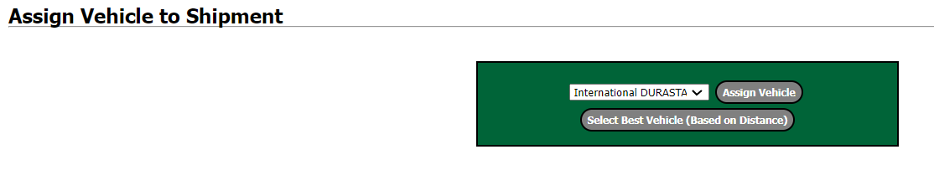

Figure 60 – Assign Vehicle to Shipment page

It also has  which allows the Carrier to choose the best vehicles based on the distance. When this button is clicked, it takes a bit while to fetch the distance details of the desired shipment and checks the vehicle list and then assigns it.

### 5.6.4 Awaiting Acceptance Shipment – CARRIER

**Carriers** are responsible for accepting or denying shipments that are direct assigned to them by shippers. Carriers will receive an email when a shipment is awaiting direct assignment. Carriers can click accept or deny for shipments in the **Shipments awaiting Acceptance screen** by clicking on the **“Green Circle Tick”** icon under **Accept column or “Red Circle Cross”** icon under **Deny** column respectively**.(Fig 47.5)**

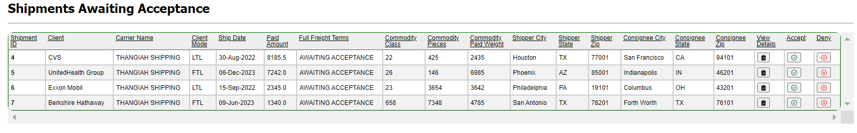

Figure 61 - The Shipments awaiting acceptance screen

### 5.6.4 all Shipment – CARRIER

**Carriers** are able to see all the shipments under one Shipment page called **All Shipments**. It consists of all the Shipments under Carrier in this page. See below for more idea about how this page looks like:

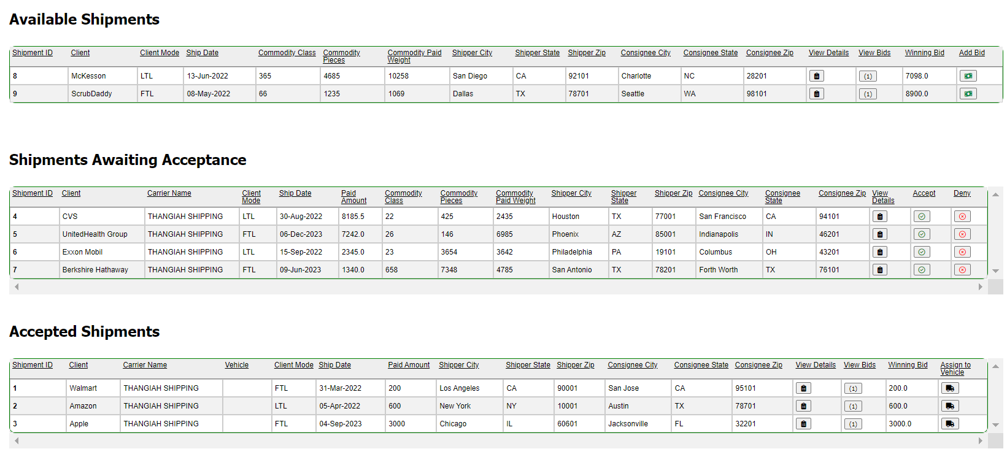

Figure 62 – All Shipments page for Carriers

## 5.7 Routes

The **Routes** tab is available to **CARRIER** user accounts to manage shipments associated with specific vehicles and specific dates/times. Both roles can display scheduled shipments for the vehicle in aggregate, if the vehicle has numerous, upcoming shipments

Carriers are able to select any vehicle which has a shipment assigned to it **(See section 4.6.3.1 for assigning vehicle to shipment)** for fetching the routes for the desired shipment. If the vehicle is available, that particular vehicle can be selected in the drop-down menu next to **Select Vehicle** for viewing the Routes of that vehicle **(Figure 63)**.

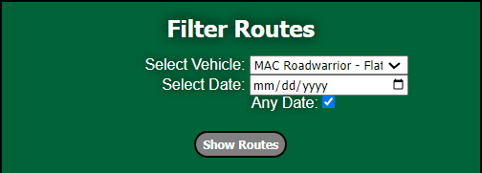

Figure 63 – Filter Route box in Routes page

After this, when clicked on **Show Routes** inside the **Filter Routes box** itself, it will generate the details of the **Selected Vehicle** in the table below like:



When clicked on  button which is present under **Show Routes on Map** (the last column) within the table, it will generate a route on the google map showing distance covered and the routes available for that vehicle **(Figure 64)**.

Here, A - B is Vehicle to Shipment and B - C is Shipment starting location to Shipment ending Location.

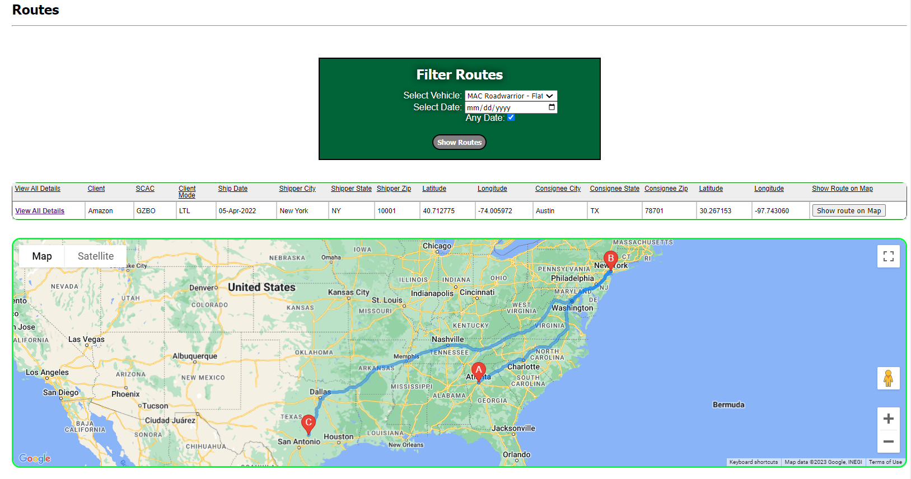

Figure 64 - Routes Page

## 5.8 Drivers

The **Drivers** tab lands the **CARRIER** user on a page displaying all relevant information/credentials on drivers registered with a specific carrier company **(Figure 65)**.

**CARRIER** users can add, edit, and delete drivers on this page.

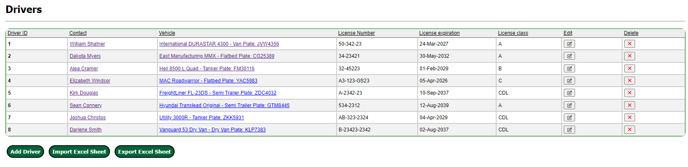

Figure 65 - Drivers Home Page for Carrier Users

### 5.8.1 ADD DRIVER

To add a driver, click on the **Add Driver** button on the data table found on the **Drivers** home page.

The user will be redirected to a form page **(Figure 66)** used to fill out all relevant information for the driver.

The required fields are as follows:

* + **Contact:** Selected from **Contacts** list (Section 3). Should match information of the **Contacts** record (Ex. John Williams)
  + **Vehicle:** Selected from **Vehicles** list (Section 7). This is the vehicle the driver drives.
  + **License Number:** The driver’s driver license number (Example: 25 624 867)
  + **License Expiration:** The expiration date of the driver’s license (Example: 05/16/2026)
  + **License Class:** The class of the driver’s license (Example: C)

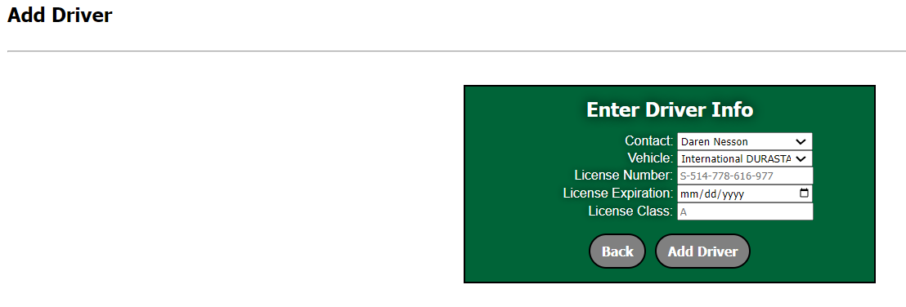

Figure 66 - Form for Carriers to Add Drivers

### 5.8.2 Update/EDIT DRIVER

To edit a driver’s information, click on the **Edit** **icon** under **Edit column** for every driver listed on the data table found on the Driver home page **(Figure 65)**.



The Carrier user will be brought to a form page identical to the **Add Driver** form seen in **Figure 66**. Here, the **CARRIER** user can alter any/all information for the specific driver they choose to edit.

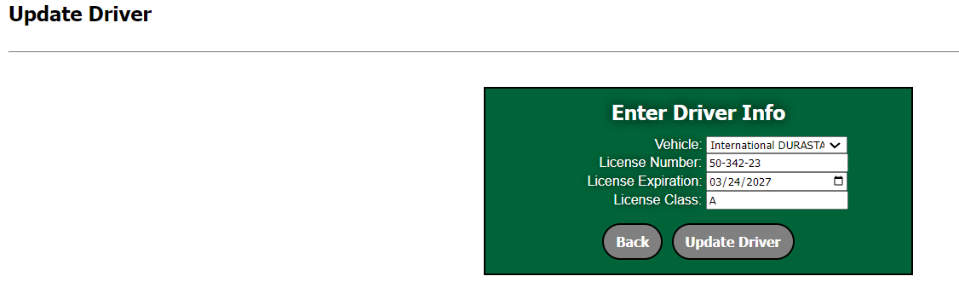

Figure 67 – Update Driver Page for Carriers

### 5.8.3 DELETE DRIVER

To delete a driver, click the **Red Cross** iconunder **Delete** column on the **Driver** page for that particular driver in the data table **(Figure 65).**



The Carrier user should see a delete confirmation dialog box **(Figure 68)** which pops-up on the window after clicking **red cross delete** icon asking whether the user wants to delete that particular driver, where they can select **Ok** to delete the driver or **Cancel** to keep the driver.

If the **Driver** is attached to another object, it cannot be deleted and gives the error: Unable to delete due to dependency conflict.

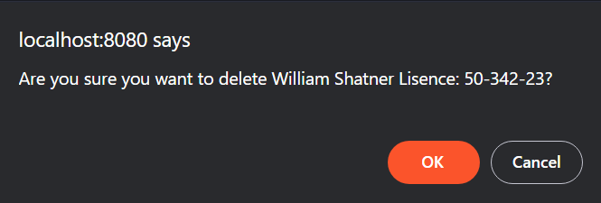

Figure 68 – Confirmation Dialog Pop-up Box to Delete Particular Driver

## 5.9 Technicians

The **Technicians** tab lands the **CARRIER** user on a page displaying all relevant information/credentials on technicians registered with a specific carrier company **(Figure 69)**.

**CARRIER** users can add, edit, and delete technicians on this page.

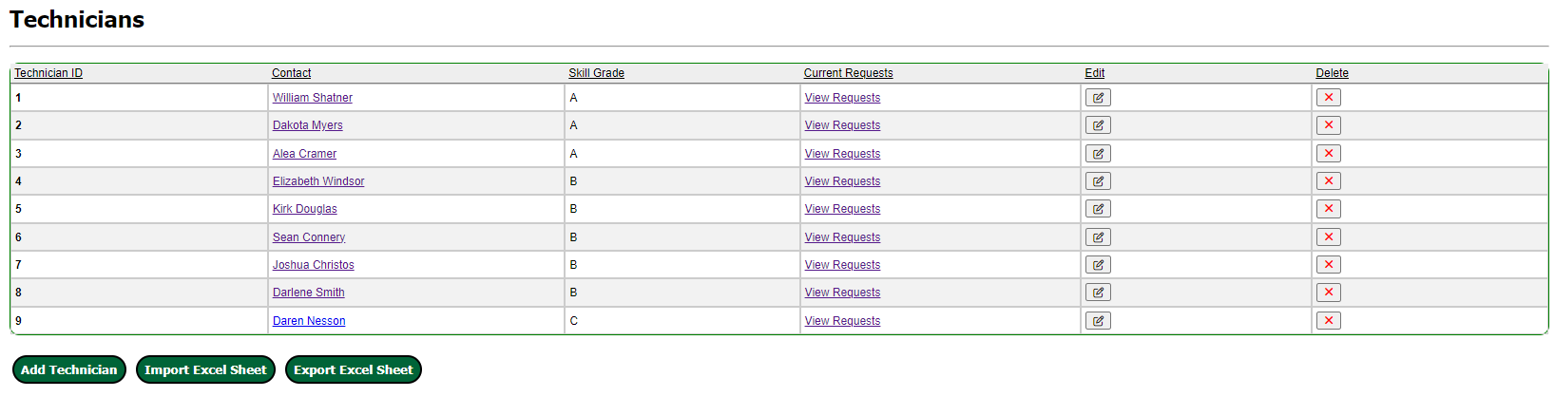

Figure 69 - Technicians Home Page for Carriers

### 5.9.1 ADD TECHNICIAN

To add a technician, click on the **Add Technician** button on the data table found on the **Technicians** home page.

The user will be redirected to a form page **(Figure 70)** used to fill out all relevant information for the technician.

The required fields are as follows:

* **Contact:** Chosen from the **Contacts** list (Section 3). This is the technician the user is adding. (Ex. John Williams)
* **Skill Grade:** A grade indicating level of proficiency for the technician (Ex. B)

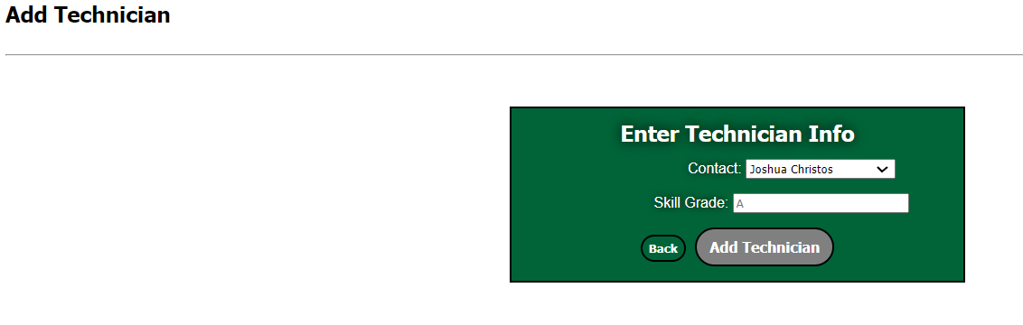

Figure 70 - Form for Carriers to Add Technician

### 5.9.2 EDIT TECHNICIAN

To edit a technician’s information, click on the **Edit** **icon** under **Edit column** for every technician listed on the data table found on the Technician home page **(Figure 69)**.



The Carrier user will be brought to a form page identical to the **Add Technician** form seen in **Figure 70**. Here, the **CARRIER** user can alter any/all information for the specific technician they choose to edit.

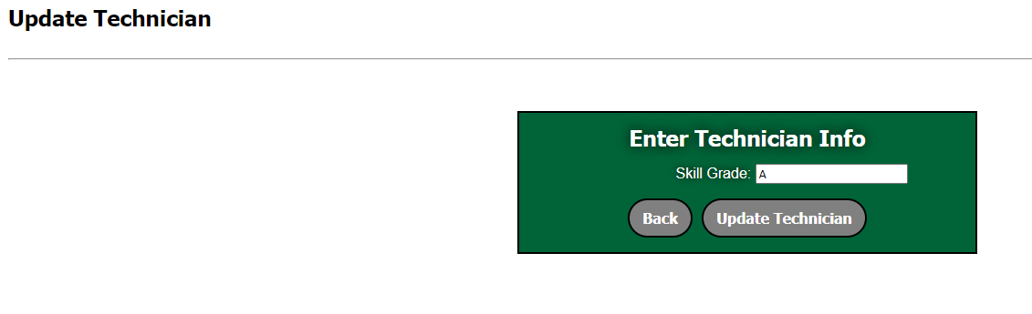

Figure 71 - Form for Carriers to Edit Technician

### 5.9.3 DELETE TECHNICIAN

To delete a technician, click the **Red Cross** iconunder **Delete** column on the **Technician** page for that particular technician in the data table **(Figure 69).**



The Carrier user should see a delete confirmation dialog box **(Figure 72)** which pops-up on the window after clicking **red cross delete** icon asking whether the user wants to delete that particular technician, where they can select **Ok** to delete the technician or **Cancel** to keep the technician.

If the **Technician** is attached to another object, it cannot be deleted and gives the error: Unable to delete due to dependency conflict.

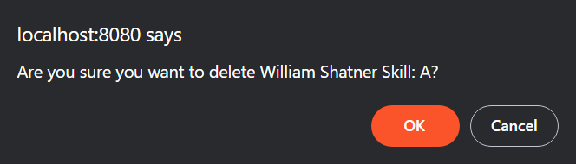

Figure 72 - Confirmation Dialog Pop-up Box to Delete Particular Technician

## 5.10 Maintenance orders

The **Maintenance** tab lands the **CARRIER** user on a page displaying all relevant information on maintenance orders submitted by the user’s carrier company **(Figure 73).**

**CARRIER** users can add, edit, and delete maintenance orders on this page.

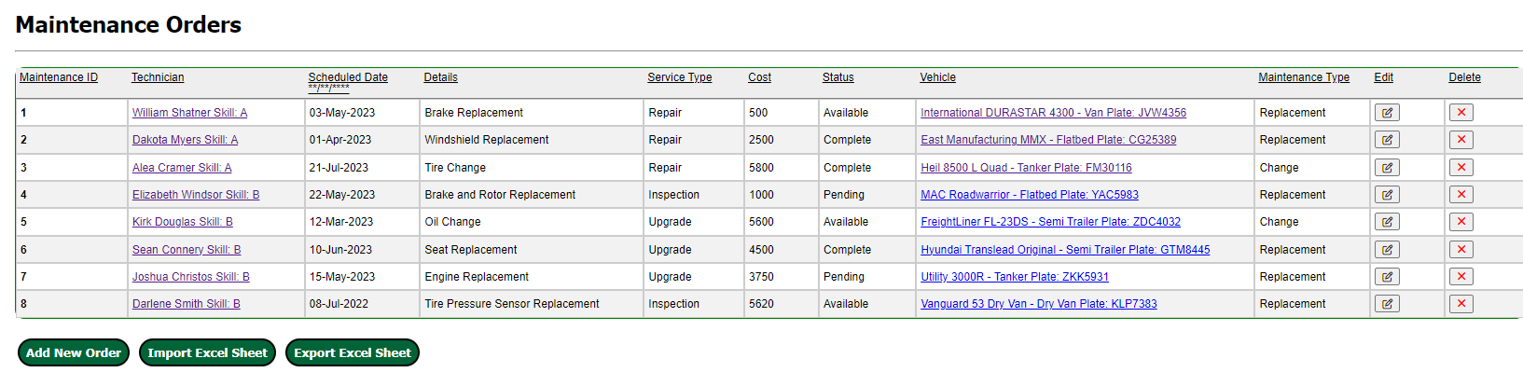

Figure 73 - Maintenance Order Home Page for Carriers

### 5.10.1 ADD MAINTENANCE ORDER

To add a maintenance order, click on the **Add New Order** button on the data table found on the **Maintenance Orders** home page.

The user will be redirected to a form page **(Figure 74)** used to fill out all relevant information for the maintenance order.

The required fields are as follows:

* **Technician:** The technician assigned to the order (Ex. John Walker)
* **Scheduled Date:** The date maintenance is to take place (Ex. 07/13/2022)
* **Details:** A description of the item to be completed (Ex. Battery Replacement)
* **Service Type:** Valid service types are repair, maintenance, replace, etc.
* **Cost:** Quote for total cost (parts & labor) of the job (Ex. $4995.99)
* **Status:** Whether the job is either **Pending** or **Completed**
* **Vehicle:** The specific vehicle requiring maintenance
* **Maintenance Type:** A general description of the location of maintenance being performed (Ex. Engine)

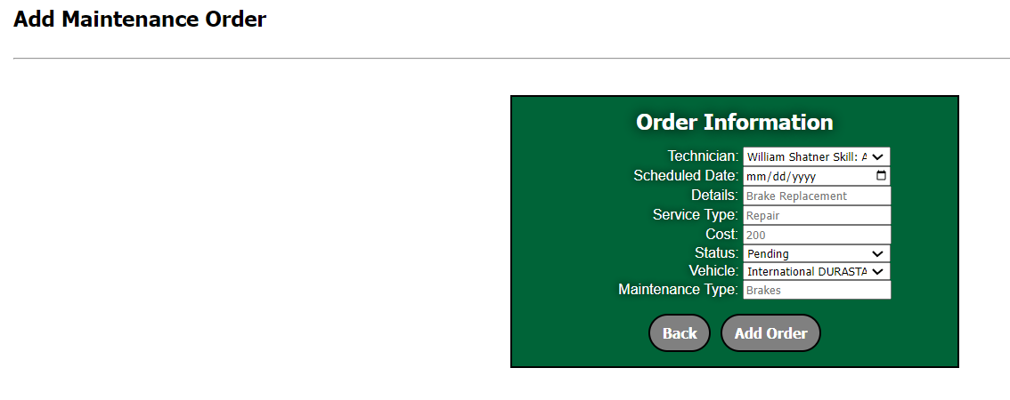

Figure 74 - Form for Carriers to Submit New Maintenance Orders

### 5.10.2 EDIT MAINTENANCE ORDER

To edit a maintenance order’s information, click on the **Edit** **icon** under **Edit column** for every maintenance order listed on the data table found on the Maintenance Order home page **(Figure73)**.



The Carrier user will be brought to a form page identical to the **Add New Order** form seen in **Figure 74**. Here, the **CARRIER** user can alter any/all information for the specific maintenance order they choose to edit.

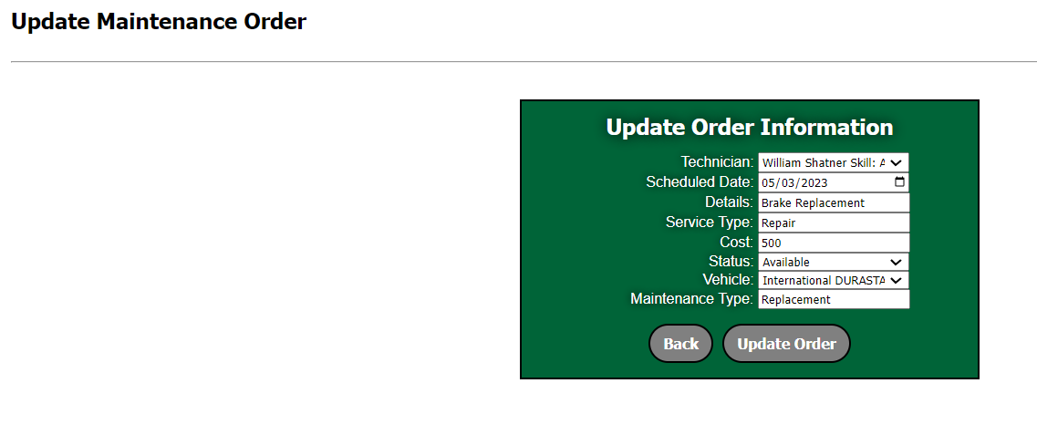

Figure 75 - Form for Carriers to Edit Maintenance Order

### 5.10.3 DELETE MAINTENANCE ORDER

To delete a maintenance order, click the **Red Cross** iconunder **Delete** column on the **Maintenance Order** page for that particular maintenance order in the data table **(Figure 69).**



The Carrier user should see a delete confirmation dialog box **(Figure 76)** which pops-up on the window after clicking **red cross delete** icon asking whether the user wants to delete that particular maintenance order, where they can select **Ok** to delete the maintenance order or **Cancel** to keep the maintenance order.

If the **Maintenance Order** is attached to another object, it cannot be deleted and gives the error: Unable to delete due to dependency conflict.

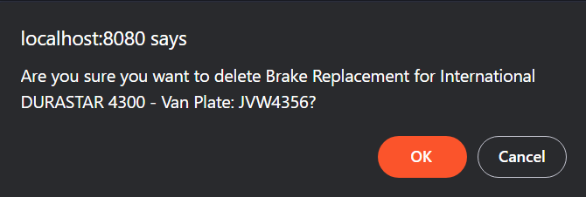

Figure 76 - Confirmation Dialog Pop-up Box to Delete Particular Maintenance Order

## 5.11 Notification system for Carrier

Carrier Users will get notifications for the following events:

* Accepting shipments bids when directly assigned.
* Winning auction on a shipment with respective ID.

The Notification count will be displayed in the top right corner or the page beside the bell icon. Click on the bell to go to the Notifications page **(Figure 77).**

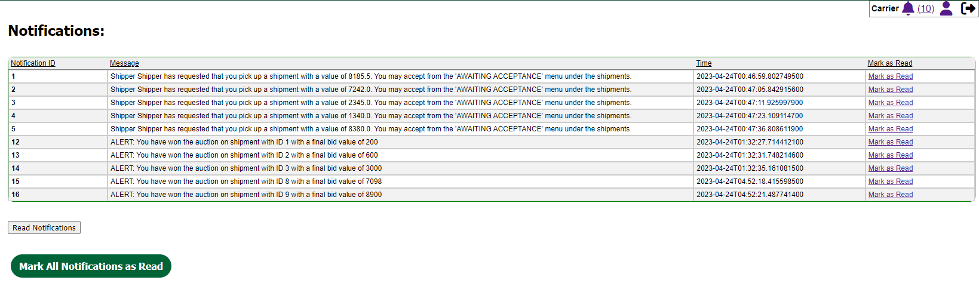

Figure 77 - Carrier Notification System Page

Notifications can be  individually or all at once by clicking the  button. The number of unread notifications the user currently has is displayed in parentheses next to the notification button on all screens **(Figure 77).**

# 6. AUCTIONEER

Auctioneer user has complete control over the auction and can do the following:

* Push shipments to auction.
* Remove shipments from auction.
* Force End an auction.
* Direct Assign shipments to carriers
* Freeze and Unfreeze Shipments.
* View, edit, and delete bids.
* Edit and Delete Shipments in any status.
* View Shipment details including routes.
* View Carrier shipments and bids.

Auctioneer also has the access to Simulations **(Detailed in section 6.3).**

When logged in as Auctioneer, you will be redirected to the All-Shipments page as the home page of this account, to show the status of all the shipments in the system.

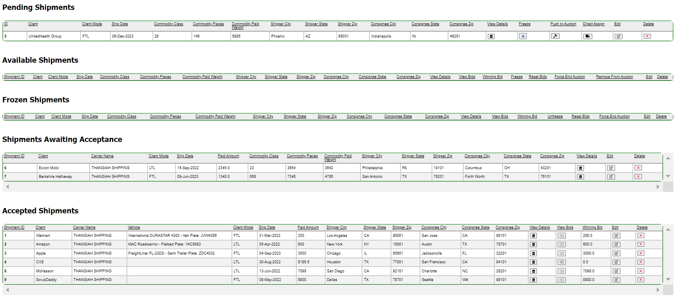

Figure 78 – Auctioneer Home Page

## 6.1 Edit User Details - auctioneer

The Auctioneer can click on the **User** icon in the top right corner of the application to change their own password and their email address. After clicking on the **User** icon, it will land up the Auctioneer on the Figure:

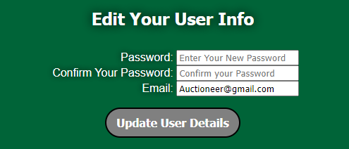

Figure 79 – Auctioneer User Edit Details Box

To navigate the Shipper user system, click on the tabs in the navigation bar shown below in **Figures 80 and 81.**

Figure 80 - Shipments Navigation Tab for Auctioneer

Figure 81 - Shipments Drop-down Menu for Auctioneer

## 6.1 auctioneer view of CARRIER

The Auctioneer can view Carrier information relative to the auction. Click on the **Carrier Tab** in the Navigation bar to access the Carrier information **(Figure 82)**.

Figure 82 - Auctioneer View of Carriers

The following information included are:

* View Carrier Shipments  (Truck icon)
* View Bids  (Money icon)

### 6.1.1 View carrier shipments

To view Carrier Shipments, click on the **Truck** icon under **View Shipments** column. Here, you can click on **Clipboard** icon under **View Details column** on the **Shipments page** and **Money** icon to **View Bids** on the **Shipments page redirected through the View Shipments** column in the **Carrier’s Tab.** View bids can also accessed on the Carrier’s tab page itself by clicking on the **Money** icon under View Bids which shows the bidsthat the carrier placed on the shipments **(Figure 83)**.

Figure 83 – Auctioneer view of Carrier Shipments

Shipment details include all the information listed in the Shipments table plus the following:

* The Carrier SCAC
* Full Freight Terms
* Shipper Location by Latitude and Longitude
* Co-signee Latitude and Longitude: Location of shipment destination
* Google Maps link for Shipper location, shipment destination, and Directions from location to destination.

### 6.1.2 View Bids

View Bids will show the Bids that the Carrier has placed on the Shipments listed **(Figure 84).**



Figure 84 – View Bids Page

#### 6.1.2.1 Edits bids

When clicked on **Edit icon** under **Edit Bids** column within the Bids page when clicked on View Bids will allow the Auctioneer to edit the bids. **(Figure 85)**



It allows the Auctioneer to change the Price in the Edit Bid page as shown in the below Figure.

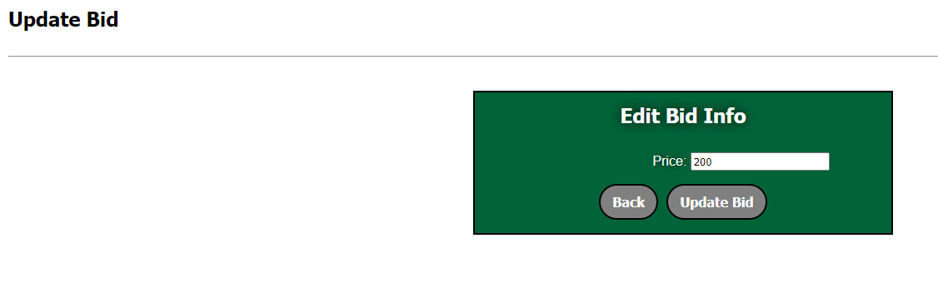

Figure 85 - Form for Carriers to Edit Bids

#### 6.1.2.2 Delete bids

To delete a bid, click the **Red Cross** iconunder **Delete** column on the **Bids** page for that particular bid selected through the **Shipments data table** from the **View Shipments** in Carrier’s tab (**Figure 22**).



The Auctioneer should see a delete confirmation dialog box **(Figure 21)** which pops-up on the window after clicking **red cross delete** icon asking whether the user wants to delete that particular bid, where they can select **Ok** to delete the bid or **Cancel** to keep the bid.

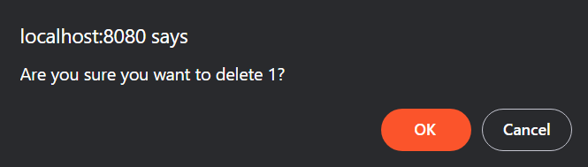

Figure 86 - Confirmation Dialog Pop-up Box to Delete Particular Bis

## 6.2 shipments in auction

This section details the Auctioneer’s role in a Shipments Auction lifecycle.

### 6.2.1 pending Shipments

**Pending Shipments** is a list of all shipments pending in the system regardless of what Shipper user created the shipment.

Figure 87 - Auctioneer View of the Pending Shipments Page

Auctioneer has Ability to do the following under Pending Shipments:

* View Details  (Clipboard Icon)
* Freeze  (Snowflake Icon)
* Push the shipment to auction  (Gavel Icon)

**Figure 48 – Master View of Pending Shipments**

* Direct Assign  (Truck Icon)
* Edit  (Edit icon)
* Delete  (Red Cross icon)

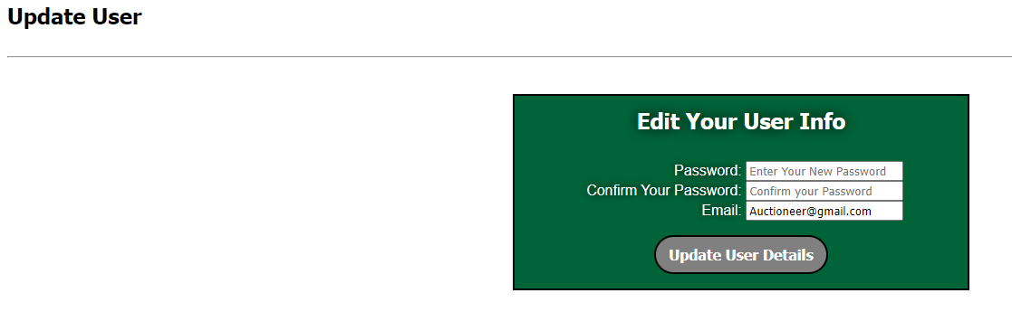

Figure 88 – Auctioneer Update User Details

### 6.2.2 FReeze SHIPMENTS

The Auctioneer can freeze shipments from the Pending Shipments table on either the All-Shipments Page or the Pending Shipments Page. To Freeze a shipment, click on **Freeze** icon under the **Freeze** column present in the Pending shipments.

When clicked a shipment to freeze, a confirmation pop up dialog box appears at the top of the screen asking if the Auctioneer wants to freeze by clicking **OK** or not by clicking on **Cancel** button ask shown below. If the Auctioneer freezes the shipment by clicking OK, the shipment moves under the **Frozen Shipments** section or table. **(Figure 90)**

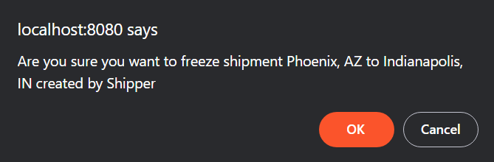

Figure 89 - Confirmation Dialog Pop-up Box to Freeze Particular Shipment

**Frozen Shipments** lists the shipments that are currently Frozen. From the Frozen Shipments Table, the Auctioneer has the ability to View and Reset Bids, Edit, Delete and Unfreeze shipments.

* **Unfreeze  (Fire Icon):** Unfreeze the shipments that were in frozen status. Moved back into previous state.
* **Reset Bids  (Refresh Icon):** Deletes all bids for the shipment.

**Note: If a shipment is put into a Freeze, it no longer shows in the auction.**

Figure 90 - Auctioneer View of Frozen Shipments

### 6.2.3 shipments awaiting acceptance

A shipment in the Shipments Awaiting Acceptance table are shipments that have been directly assigned to a Carrier in the system. Until the Carrier accepts or denies the shipment, it will reside here **(Figure 91).**

Figure 91 - Auctioneer View of the Shipments Awaiting Acceptance Page

While a shipment is in this state, the Auctioneer can Edit or Delete it each shipment and also view their details.

### 6.2.4 Available shipments

**Available Shipments** lists the shipments in auction. From here, the auctioneer can do the following:

* **View Details:** View the details of the available shipments.
* **View Bids**: view all bids for all shipments in auction.
* **Freeze:** Suspends the shipment from being in auction until Auctioneer unfreezes it.
* **Reset Bids:** Deletes all bids for the shipment.
* **Force End Auction ** (Red Gavel icon): Forces the auction to end. The lowest bidder is assigned the shipment.
* **Remove from Auction ** (Ban Gavel Icon)**:** Removes the shipment from auction.

Figure 92 - Auctioneer View of Available Shipments

### 6.2.5 accepted shipments

**Accepted Shipments** page is a list of all shipments accepted by all carriers. shipment details and bids, edit (work in progress), Delete shipment, and Reset Bids.

* **View Details:** Shipment Details page is displayed.
* **View Bids**: view all bids for all shipments in auction.
* **Reset Bids:** Deletes all bids for the shipment.

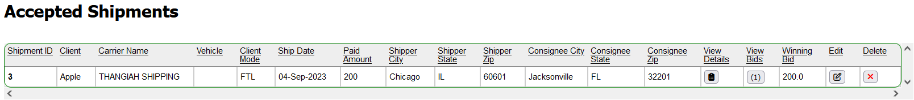

Figure 93 - Auctioneer View of Accepted Shipments

## 6.3 Simulations

Simulations are accessed through the Auction user account by clicking on the Simulation tab in the Navigation Bar. The simulations available are:

**Figure 50 – Master View of Frozen Shipments**

* Start Bidding Sim: Simulates the bidding process.
* Start Direct Assignment Sim: Simulates the Direst Assignment of a shipment.

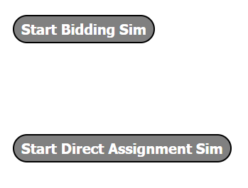

Figure 94 – Auctioneer Simulation

# 7. Shadow Admin

The Shadow Admin oversees the admin role and keeps track of the system logs for all users. They keep a track of add or delete or logged in or logged out along with the time and date of all the following events occurred. Their profile is the top level above the admin user itself so the admin cannot delete any user associated with **SHADOWADMIN** role. They have a log entry table and are able to filter logs and export them or the filtered logs.

## 7.1 Logs

The **Logs** tab is available to **SHADOW ADMIN** user accounts. The purpose of this page is to display all of the logs to the user. The logs include when the database is manipulated and when a user login/logout along with time and date of modification or manipulation. **Graphical user interface, text, application, email
**

Figure 95 – Shadow Admin Home Page with Logs Entry

## 7.2 Filtering & Exporting logs

Shadow Admins have the ability to filter the logs based on the **User**, **Level**, and **Date Range**. They may also export the logs as an excel file.



Figure 96 – Logs filtering Box

When clicked on the drop-down menu for User, Level, Start and End date (Date Range) respectively, Shadow admin user can:

* **User**: Choose if they want to view any particular user logs such as Shipper user or Carrier user or Auctioneer or Admin user.
* Level: Separate the error logs and the informative logs of each user.
* Date Range: A start date and end date can be set for gathering logs of those particular dates only.

After choosing the desired filter, click  button to view the filtered changes. To reset the filtered changes, click on  button towards the right of **Apply** button. To export the logs or the filtered logs click on  button and choose the desired location to save the log excel file.

# 8. Figures

**Figure 1 – Home Page of System (Content-Push Nav-Bar Open)** **4**

**Figure 2 – Home Page of System (Content-Push Nav-Bar Closed)** **4**

**Figure 3 – Registration Home Page** **5**

**Figure 4 – Shipper Account Registration Page** **6**

**Figure 5 – Shipper Registration Page Captcha** **7**

**Figure 6 – Carrier Registration Form** **8**

**Figure 7 – Login Page** **9**

**Figure 8 –Admin Account Navigation bar and Tabs** **9**

**Figure 9 -** **Admin All Users Table and Home Page** **11**

**Figure 10 –** **Admin All User Add User Home Page** **12**

**Figure 11 –** **Admin to Add Other User Page**  **12**

**Figure 12 – Edit Shipper User Page**  **13**

**Figure 13 – Delete User Confirmation Pop-up above screen** **13**

**Figure 14 – View Available Roles Button in All User page** **14**

**Figure 15 – User Associated with Roles Available in the System** **14**

**Figure 16 – Database Page in Database Tab 14**

**Figure 17 – Admin Update User Details 15**

**Figure 18 – Shipper Update User Details 16**

**Figure 19 – Shipper Navigation Bar 16**

**Figure 20 – Shipper Navigation Bar and its Tabs 16**

**Figure 21 – Upload Page for Freight Rate Table 17**

**Figure 22 – Freight Rate Table for SCAC – GZBO in Upload Freight Table Page 17**

**Figure 23 –** **Add a New Shipment Page**  **18**

**Figure 24 – Upload Excel File Page after clicking on Import Excel Sheet.** **19**

**Figure 25 – Upload shipment from excel success message 19**

**Figure 26 – Upload shipment from excel error message 20**

**Figure 27 – Carrier to Assign Shipments Page 20**

**Figure 28 – Shipment Directly Assigned moved under Shipment Awaiting Acceptance Table 20**

**Figure 29 - Push Shipment Confirmation Pop-up above screen 21**

**Figure 30 – Available Shipment Page after pushing shipment from Pending Shipments 21**

**Figure 31 – Shipment Bids page 22**

**Figure 32 – Accepted Shipments Page after Accepting Bid on Figure 31 22**

**Figure 33 – Frozen Shipment Page 22**

**Figure 34 – Shipper Notification System Page 23**

**Figure 35 –** **Updating Carriers Page**  **23**

**Figure 36 – Upload Excel File Page after clicking on Import Excel Sheet 24**

**Figure 37 – Upload Contacts from excel success message 24**

**Figure 38 – Error message for incorrect excel file or wrong format of desired excel file 24**

**Figure 39 - Contacts Page for Carrier Users 25**

**Figure 40 –** **Form for Carrier to Add a Contact**  **25**

**Figure 41 –** **Form for Carrier to Edit a Contact** **26**

**Figure 42 - Delete Contact Confirmation Pop-up above screen 26**

**Figure 43 – Locations Page for Carrier Account** **27**

**Figure 44 – Form to Add New Location** **27**

**Figure 45 - Form to Edit Location 28**

**Figure 46 – Confirmation Pop - up to Delete Particular Locations** **28**

**Figure 47 – Vehicles Home Page for Carrier Accounts** **28**

**Figure 48 – Form for Carrier to Add a Contact** **29**

**Figure 49 - Form for Carrier to Edit Vehicle 29**

**Figure 50 – Confirmation Dialog Pop-up Box to Delete Particular Vehicle** **30**

**Figure 51 –** **Vehicle Types Home Page** **31**

**Figure 52 – Form for Carriers to Add a New Vehicle Type** **32**

**Figure 53 –** **Form for Carriers to Edit Vehicle Type**  **33**

**Figure 54 – Confirmation Dialog Pop-up Box to Delete Particular Vehicle Type 33**

**Figure 55 - Carrier View of the Available Shipments Page** **34**

**Figure** **56 - Form to Add a Bid** **34**

**Figure 57 - Form to Edit a Bid in Available Shipment** **35**

**Figure 58 – Carrier View of Accepted Shipments for that Carrier** **35**

**Figure 59 - Carrier View of Shipment Details** **35**

**Figure 60 - Assign Vehicle to Shipment page** **36**

**Figure 61 - The Shipments awaiting acceptance screen 36**

**Figure 62 – All Shipments page for Carriers 36**

**Figure 63 – Filter Route box in Routes page 37**

**Figure** **64 - Routes Page** **47**

**Figure 65 – Drivers Home Page for Carrier Users** **37**

**Figure 66 –** **Form for Carriers to Add Drivers** **38**

**Figure 67 – Update Driver Page for Carriers 38**

**Figure 68 – Confirmation Dialog Pop-up Box to Delete Particular Driver 39**

**Figure 69 – Technicians Home Page for Carriers** **39**

**Figure 70 – Form for Carriers to Add Technician** **40**

**Figure 71 –** **Form for Carriers to Edit Technician**  **40**

**Figure 72 – Confirmation Dialog Pop-up Box to Delete Particular Technician 41**

**Figure 73 – Maintenance Order Home Page for Carriers** **41**

**Figure 74 –** **Form for Carriers to Submit New Maintenance Orders** **42**

**Figure 75 –** **Form for Carriers to Edit Maintenance Order**  **43**

**Figure 76 –** **Confirmation Dialog Pop-up Box to Delete Particular Maintenance Order 44**

**Figure 77 –** **Carrier Notification System Page 44**

**Figure 78 – Auctioneer Home Page 45**

**Figure 79 – Auctioneer User Edit Details Box 45**

**Figure 80 –** **Shipments Navigation Tab for Auctioneer 46**

**Figure 81 –** **Shipments Drop-down Menu for Auctioneer 46**

**Figure 82 - Auctioneer View of Carriers 46**

**Figure 83 – Auctioneer view of Carrier Shipments 47**

**Figure 84 – View Bids Page 47**

**Figure 85 –** **Form for Carriers to Edit Bids**  **48**

**Figure 86 –** **Confirmation Dialog Pop-up Box to Delete Particular Bid 48**

**Figure 87 –** **Auctioneer View of the Pending Shipments Page** **49**

**Figure 88 – Auctioneer Update User Details 49**

**Figure 89 –** **Confirmation Dialog Pop-up Box to Freeze Particular Shipment 50**

**Figure 90 –** **Auctioneer View of Frozen Shipments** **50**

**Figure 91 –** **Auctioneer View of the Shipments Awaiting Acceptance Page** **50**

**Figure 92 –** **Auctioneer View of Available Shipments** **51**

**Figure 93 -** **Auctioneer View of Accepted Shipments** **51**

**Figure 94 – Auctioneer Simulation 52**

**Figure 95 – Shadow Admin Home Page with Logs Entry 52**

**Figure 96 – Logs filtering Box 53**